## Introduction

Ecosystems around the world are facing rapid and unpredictable climatic changes (IPCC 2021). Over the past 50 years, many regions have faced decreased precipitation, increased temperatures, and longer durations between precipitation events (Spinoni et al., 2019) and this trend is expected to accelerate across many landscapes in the coming decade (Dai, 2011). These drought events, driven by climate change, pose a significant problem for plant populations and communities. In response to these changes, most organisms are expected to (1) migrate, (2) undergo adaptive genetic changes, and/or (3) exhibit phenotypic plasticity (Hoffmann & Sgrò, 2011). As sessile organisms, it is unlikely that most plant populations will be able to keep pace with these climatic changes on an evolutionary scale and may not migrate fast enough to persist (Song et al., 2021). Phenotypic plasticity, however, can allow plants to rapidly respond to fluctuations in environmental variation. Phenotypic plasticity is most often considered in the contexts of individuals responding to their immediate environment, with the range of expression limited by evolution and genetic factors. However, there is increasing evidence that environmental conditions experienced by parent plants can influence the phenotype and degree of plasticity in offspring generations (Bonduriansky, 2021; Herman & Sultan, 2011; Uller, 2008). Termed “transgenerational plasticity” (TGP), this mechanism may represent an additional mechanism by which species cope with a shifting climate.

This form on non-genetic inheritance may serve as a source of phenotypic variation with significant evolutionary consequences, particularly if it influences offspring fitness (Donelson et al., 2018; Herman & Sultan, 2011). In many cases, exposure to environmental stress across multiple generations can have a positive anticipatory effect, improving offspring performance under similar stressful conditions (Bonduriansky, 2021; J. Marshall & Uller, 2007; Yin et al., 2019). Adaptive TGP occurs when parental exposure to an environmental stressor enhances offspring fitness in response to the same environmental stressor (Bell & Hellmann, 2019; Colicchio & Herman, 2020; Donelson et al., 2018; Engqvist & Reinhold, 2016). Because adaptive TGP can induce beneficial phenotypic changes within just a single generation and affect many offspring, it may enhance population persistence in stressful environments that might otherwise reduce fitness (Herman & Sultan, 2011).

However, in the past two decades, it has become clear that the effects of TGP are diverse, not necessarily always adaptive, and complex (reviewed in Bonduriansky, 2021; Holeski et al., 2012; Mousseau & Fox, 1998; Uller, 2008; Yin et al., 2019). For example, when exposed to two generations of drought treatments, offspring of the perennial grass *Secale sylvestre* exhibited higher aboveground biomass and higher seed production compared to offspring of control (non-droughted) parental plants (Mojzes et al., 2021). This adaptive TGP effect is not always consistent, however. For example, when the annual leguminous herb *Lupinus angustifolius* was exposed to two generations of drought, offspring from this treatment exhibited significantly reduced seed mass and lower reproductive biomass (Matesanz et al., 2022). While the number of studies investigating transgenerational plasticity in the past two decades has risen exponentially, no clear patterns have emerged as to the adaptive benefit of transgenerational effects, and several published meta-analyses have reached opposite conclusions on the perceived benefits of transgenerational plasticity (Sánchez-Tójar et al., 2020; Uller et al., 2013; Yin et al., 2019).

Fewer studies have considered how environmental conditions influence the degree of transgenerational plasticity across populations of species (Groot et al., 2017; Lampei et al., 2017; Riginos et al., 2023; Wadgymar et al., 2018), and among genotypes within populations (Galloway, 2001; Holeski, 2007; Latzel et al., 2014). Despite the large number of studies examining the effects of TGP, less is known about how environmental conditions influence the degree of transgenerational plasticity across populations of species. Different factors, including local climate variables and patterns of environmental heterogeneity across years, may results in populations expressing transgenerational effects differently, or not at all. Experiments designed to include climatically distinct populations may offer valuable insight on the role of local climate regimes on the evolution of TGP between populations (Groot et al., 2017).

Transgenerational plasticity is more likely to arise within a population when environmental fluctuations occur predictably across generations, there is little or no cost to a plastic response, and when environmental cues are reliable indicators of future conditions (Colicchio & Herman, 2020; Hoyle & Ezard, 2012; Räsänen & Kruuk, 2007; Reed et al., 2010; Uller, 2008). TGP is particularly favored when parental and offspring environments are correlated or fluctuate predictably over time, allowing parents to adjust offspring phenotypes in ways that can enhance both their own fitness and offspring fitness, making TGP adaptive (Burgess & Marshall, 2014; J. Marshall & Uller, 2007; Kuijper & Hoyle, 2015). However, TGP may also manifest in different offspring reactions depending on environmental predictability. When future conditions are uncertain—when environments fluctuate more unpredictably—parent plants may prioritize their own fitness over their offspring, or may produce more diverse offspring phenotypes to reduce fitness variability (bet hedging) (Fischer et al., 2011; J. Marshall & Uller, 2007).

While TGP can enhance offspring fitness, its expression likely depends on the environmental and ecological context of a population or species’ home site. Quantifying the impact of population homesite environment on TGP expression is imperative to understanding parental effects on fitness and performance. This is one confounding factor that may account for obscure results in transgenerational studies as mentioned above—variance in parental effects on populations collected from environmentally distinct sites, or lack of variance in plants collected from the same genetic pool (Nicotra et al., 2010; Sultan, 1987). For example, Latzel et al. found strong evidence for parental effects in *Arabidopsis thaliana* in response to a wide variety of abiotic stressors*,* with the effects being strongly dependent on genotype and often acting in different directions and magnitudes depending on the genotype (Latzel et al., 2023). Wadgymar et al. found that in populations of *Boechera stricta* distributed across an elevational gradient, low elevation populations had greater transgenerational plasticity than within generational plasticity in germination success than higher-elevation populations (Wadgymar et al., 2018). Transgenerational and within generation plasticity likely mediate fitness and performance across genetically different populations. Understanding how climatically distinct populations influence parental effects between populations may offer valuable insights to understanding how plant populations might respond to a changing climate.

One key environmental factor influencing the potential for TGP is water availability, which strongly impacts plant performance, driving major plant species distributions across the world (Bartlett et al., 2012; Cornwell & Ackerly, 2009; Louthan et al., 2015). As climate change progresses, increasing aridity poses a significant concern, potentially shifting plant distributions and leading to local extinction events. Aridity is associated with higher temperatures and drier conditions, both of which act together to increase physiological stress and affect plant growth and reproduction. One measure of this physiological stress is vapor pressure deficit (VPD), or the difference in the amount of moisture in the air vs. fully saturated air, combining the effect of precipitation and temperature into one physiologically relevant metric. With increasing VPD, transpiration increases, increasing the water demand needed to maintain turgor pressure and generally negatively impacting plant survival, growth, and reproduction. As the frequency and severity of droughts continues to rise (Dai, 2011), understanding how multi-year droughts affects potential transgenerational plasticity in performance and fitness traits is imperative for predicting plant population response to climate change.

In this study, we assessed the effects of parental collection environment variability and experimentally imposed water limitation on TGP in the annual herbaceous plant *Plantago patagonica*. We also sought to quantify whether any induced plasticity was adaptive, resulting in better performance in terms of survival, growth, and fecundity in populations exhibiting TGP. We used eleven populations collected from abiotically distinct and contrasting environments located across the southwestern portion of the US (Table 1) that differed in both growing season (spring) VPD and variation in spring VPD across a 30 year period (I think?). Seeds from these populations were grown under water limitation and control treatments prior to this experiment (see Klein and Mitchell 2025 for more detail). Using seeds derived from this experiment, we implimented a fully factorial greenhouse experiment, with watering limitation treatments that were early (10-14 days after germination) and strong (representing a 50% reduction in spring annual precipitation for our driest population). This resulted in cohorts of offspring that had experience four different levels of parental water ranging from no water limitation to two generations of water limitation. To assess the presence and magnitude of transgenerational plasticity, and how it interacts with home site spring VPD variability, we measured several performance and fitness traits for each cohort. We asked the following questions: 1) Is there evidence of TGP in response to water limitation in *P. patagonica*? 2) Does collection site climate variability predict the magnitude of the TGP response to water limitation? and 3) Is TGP response to water limitation adaptive?

## Materials and methods

***Study species, source populations, and seed collection***

*Plantago patagonica* (woolly plantain) is a small statured, fully self-pollinating annual forb (due to parenthesis cleistogamy; Sharma et al., 1992) with a broad biogeographic range extending across North America, into northern Mexico, and occurring in parts of South America. *P. patagonica* is characterized by a basal cluster of hairy, grass-like leaves with dense spikes of white and green flowers. In North America, *P. patagonica* is a common winter and spring annual that often forms dense mats (SEINet Portal Network, 2024). *P. patagonica* is a fitting plant to test the occurrence of transgenerational effects due to its wide natural range and reliable inbreeding. Within the southwestern portion of North America, *P. patagonica* has been identified as a priority restoration species by the Bureau of Land Management’s Colorado Platea Native Plant Program due to its high likelihood for establishment in large scale projects (Wood et al., 2015), high germination probability (Gremer & Venable, 2014), its ability to seed bank (Haight et al., 2019), and its potential role in promoting perennial establishment (Barak et al., 2015). We used plant material from 11 different populations of *P. patagonica* sourced from locations ranging in growing season VPD (spring VPD from 3.62 kPa to 2.02 kPa, see Figure 1). See Klein & Mitchell (2024) for a detailed description of seed sources and acquisition.

***Water Limitation Experiments***

**F1 - Common Garden Experiment**

This experiment leveraged seeds generated as part of 2021 study detailed in Klein & Mitchell et al. 2024. The F1 experiment was performed in a common garden located at the Petchesky Conservation Center on New Mexico Land Conservancy-owned land southwest of Santa Fe, New Mexico, U.S.A. (*35.612602, −106.004360*). The 262-acre conservation area is dominated by grasslands and pinyon–juniper woodlands, which is representative of the typical *P. patagonica* habitat in the Southwest. The common garden has a 30-year MAP of 331 mm and ranges annually in temperature from −0.30 to 22°C, which is intermediate in precipitation and temperature compared to collection conditions for our 11 populations.

During the F1 experiment, we used wild collected seed (collected from locations detailed in Figure 1) and grew them under one of two watering treatments: supplemental watering and ambient watering. Individuals grown under the supplemental watering treatment received 200% of the 30-year average at the common garden (~96mm), while the ambient watering received approximately 100% of the 30-year normal for the growing season (~48mm). For further details on the F1 common garden experiment, see Klein & Mitchell, 2024. The offspring seed (F2, Figure 2) of these plants were collected, cleaned, and stored for later use. For the purposes of our experiment, we considered individuals grown under ambient conditions to be “dry” and those under supplemental conditions to be “control”.

**F2 - Greenhouse experiment**

Seeds produced from the F1 common garden were used in a F2 greenhouse water limitation experiment (Figure 2) during the spring and summer of 2023 (April – August). Seeds from population 2 were misplaced and not recovered, so only 11 populations were represented in F2. Seeds from each population and each watering treatment were scarified with 150-grit sandpaper, soaked for 24 hours in tap water, and planted in 2-in x 8-in “cone-tainers” (Stuewe & Sons, Tangent, OR, USA). We sowed 5-8 seeds per pot in a 50-50 mixture of sterilized potting soil and sand and watered all pots to saturation for the first 14 days to ensure germination. The planting substrate was sterilized via an autoclave at 121 C for 3 consecutive days. The greenhouse was maintained between 64-85 F under ambient light conditions from April to August 2023. No fertilizer was applied over the course of the experiment. On day 14, we thinned each cone-tainer to a single individual per pot and randomly assigned plants to one of two watering treatment in a fully factorial fashion (Figure 1). The final experimental design was comprised of: 11 maternal populations X two F1 watering treatments (control and dry) X two F2 watering treatments (control x dry) X 48 individuals = 2112 plants, resulting in four treatment cohorts: DD (F1 dry / F2 dry), DC (F1 dry / F2 control), CD (F1 control / F2 dry), and CC (F1 control / F2 control) (Figure 2).

To maximize differences between our two water treatments, plants in the control treatment received water equal to the 30-year mean spring (March-June) rainfall amounts for the wettest seed source location in our study (60ml/week). Beginning on day 14 of the experiment, plants in the dry treatment group were watered at a rate of 50% of the 30-year mean spring rainfall amount for the driest location in our study (15ml/week) (PRISM Climate Group). Plant stress (an observed and sustained loss of turgor pressure even with watering) was initially very high in the dry treatment, so watering was increased to 30ml/week on day 18 to ensure adequate survival and replication in the treatment group. Watering occurred twice per week at 15 ml (dry) and 30 ml (control) per watering using a graduated 100ml syringe.

**Figure 1.** a) Collection locations and b) growing season climate characteristics for each population of *Plantago patagonica.* Spring climate characteristics were averaged across 30 years (1989 – 2019, April – June). SVPD = spring VPD.

**b)**

**a)**



**Figure 2.** Schematic of the fully factorial experimental design detailing F1 and F2 generations. We collected seeds from individuals in natural *Plantago patagonica* populations across a climatic gradient in AZ, UT, NM, and CO (Figure 1). In F1, these seeds were reared in a common-garden experiment and exposed to two experimental watering conditions. In F2, seeds from F1 were reared in a greenhouse experimental and again exposed to two experimental watering conditions, resulting four cohort groups: CC, CD, DC, and DD, as outlined in the text.

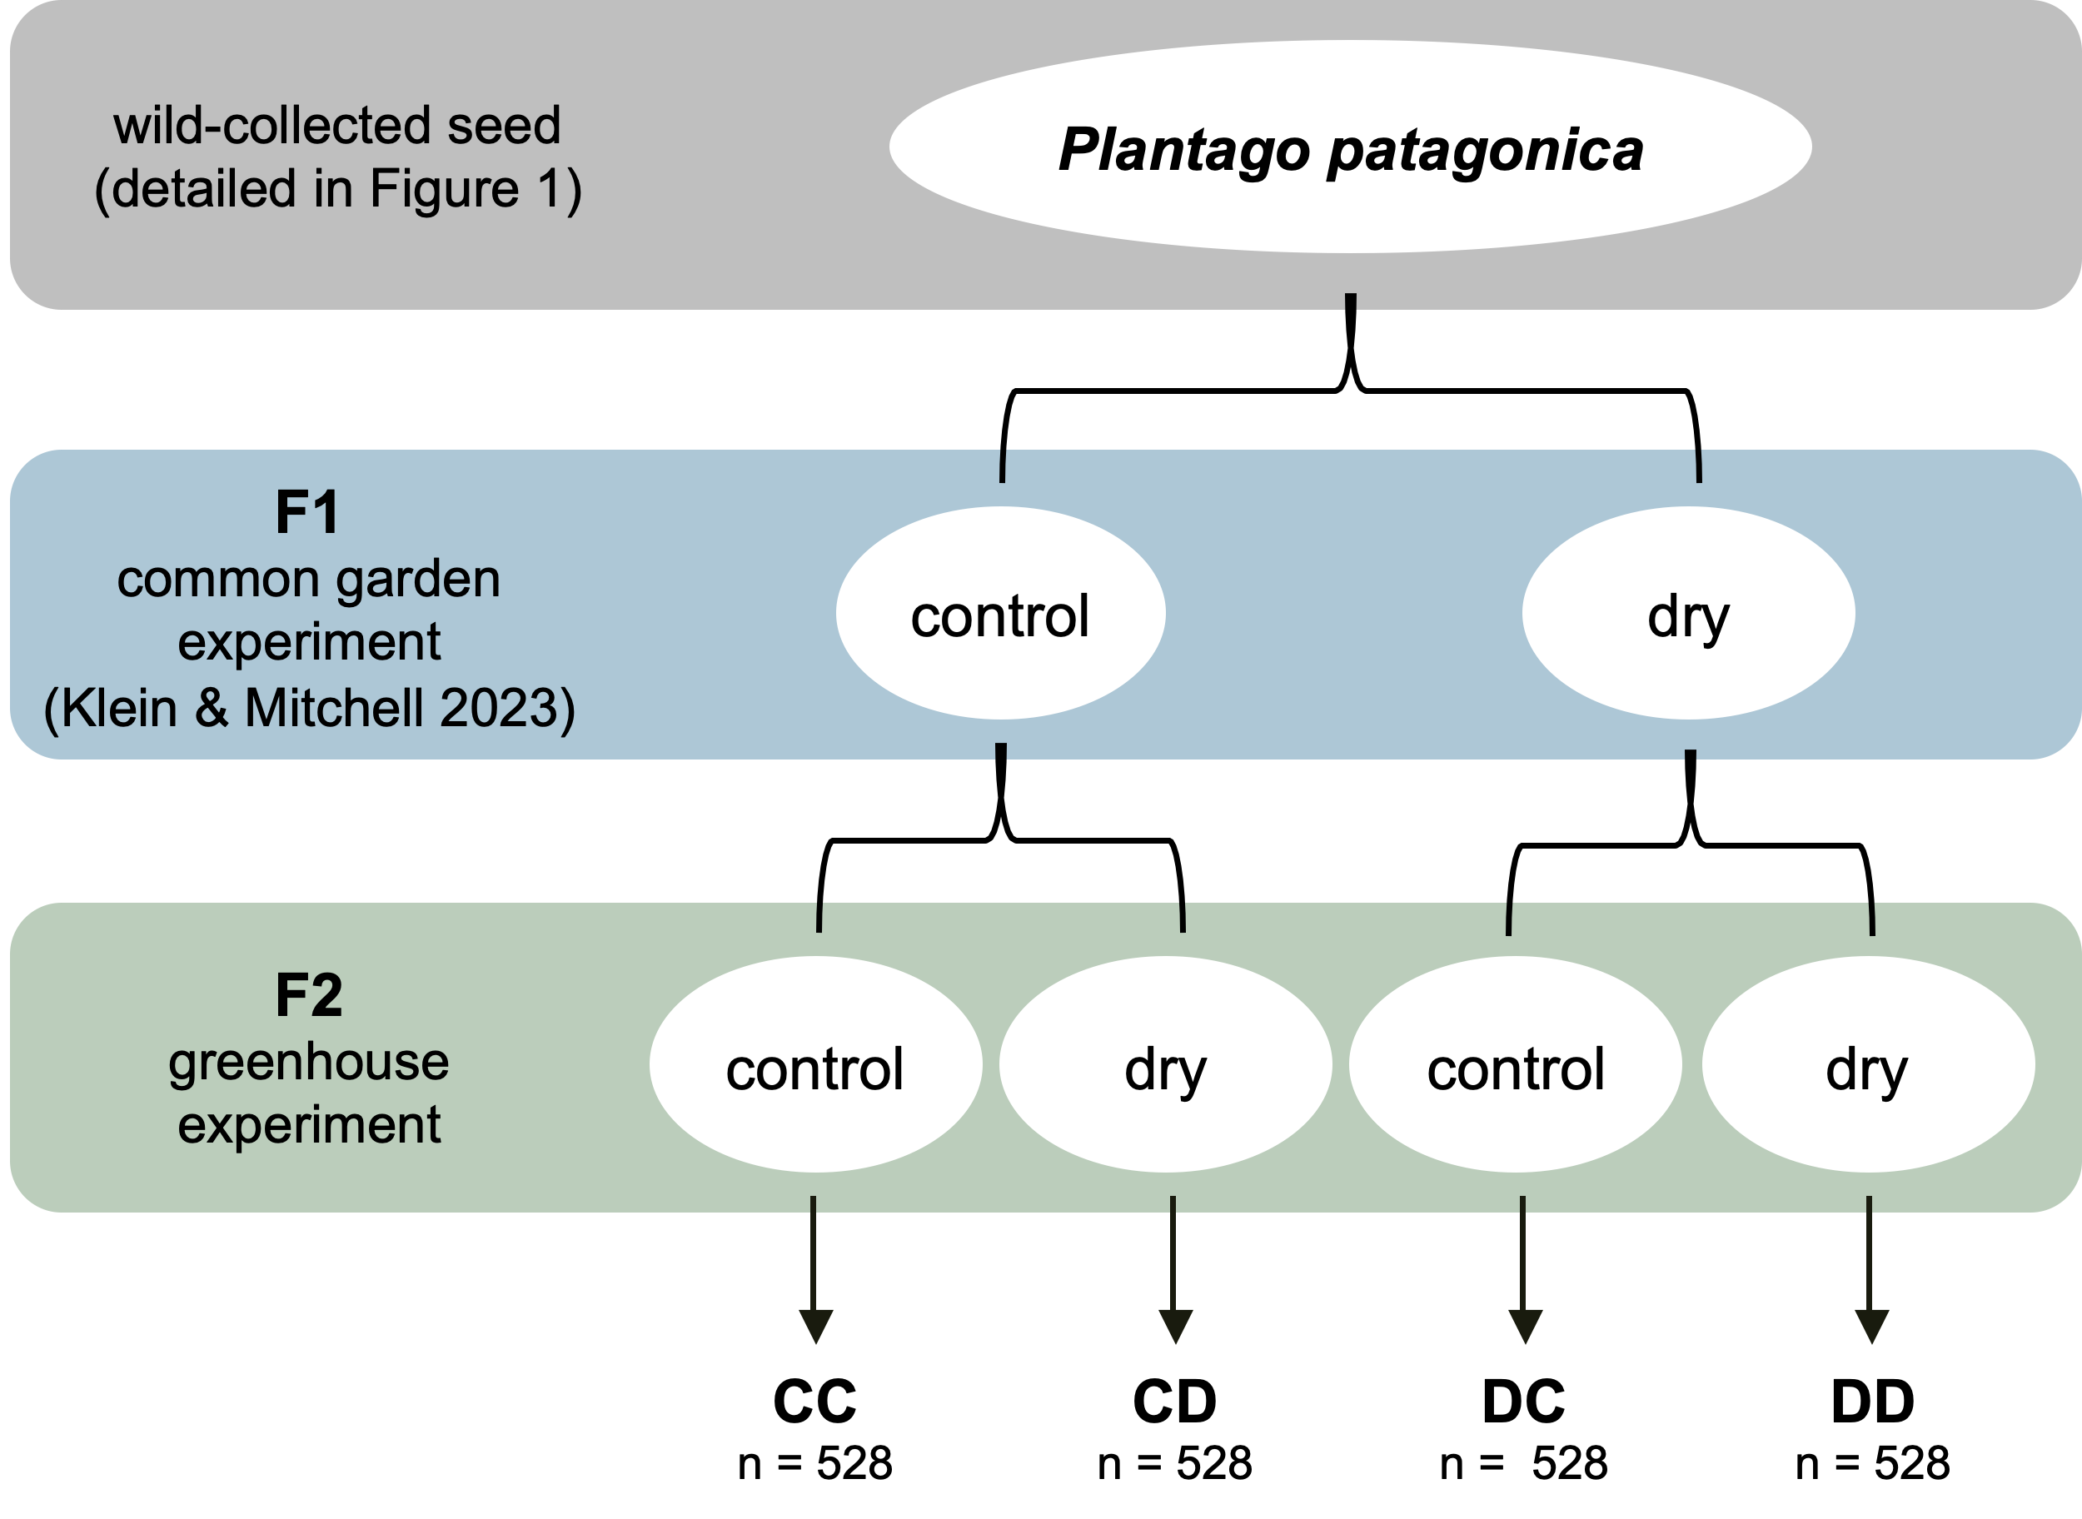

***Trait data collection***

To understand the transgenerational effects of drought in *P. patagonica*, we quantified traits related to growth (root biomass, shoot biomass, total biomass, and maximum vegetative height), resource allocation (root:shoot ratio, relative growth rate, SLA, and LDMC), survival, and reproduction (days to flower, number flowered, number of flowering structures per plant, and seed number) in the F2 generation in response to each multi-generational watering treatment. Germination was monitored daily for 20 days, with number of germinates per day recorded. Plant height (mm), indicative of a plant’s ability to compete for light (Westoby, 1998), was measured every seven days for four weeks, and then every 14 days for four weeks beginning on day 35. Final height was determined as the maximum vegetative tissue height on day 50.

To categorize *P. patagonica* on the leaf economics spectrum, which characterizes a species capacity for stress tolerance vs. resource acquisition (Wright et al., 2004), we measured relative growth rate (RGR), SLA, and LDMC. We calculated relative growth rate with the height data, using the following formula, where initial size was height on day 14 and final size was height on day 50 (Crawley, 2009):

RGR = ln (final size / initial size)

On day 60, we collected one to five mature, healthy leaves per individual to measure SLA and LDMC. Collected leaves were stored in zip lock bags with one water-saturated paper towel sheet and placed overnight in cool, dark conditions (35**°** F). After 12-14 hours, leaves were weighed with a microbalance (1-μg precision; Mettler Toledo) to obtain saturated weight. The leaves were then scanned using a LI-COR LI-3100C leaf scanner to quantify leaf area. Leaves were then dried for 48 hours in an oven at 60**°** C and then weighed again using the Mettler Toledo microbalance. Specific leaf area (SLA) was calculated as the area of fresh leaf divided by the oven dried mass. Leaf dry matter content was calculated as the leaf dry weight divided by the saturated leaf weight.

Plant mortality, presence of reproductive structures, and number of reproductive structures was monitored daily throughout the term of the experiment, from May 18th, 2023, to August 10th, 2023. Here, mortality represents proportion of plants alive on day 50. After each plant had finished flowering and the seed heads had begun to ripen but before the plant had fully senesced, seed heads were collected and stored for further drying. Root, shoot, and total biomass was collected immediately after seed collection. Biomass allocation was calculated as the root:shoot (R:S) ratio. The mass of the removed leaves was added back to the total aboveground biomass for each individual for analysis. The collected seedheads were placed in paper envelopes and dried for 3 months in a temperature-controlled laboratory room. Seedheads were then manually cleaned. We collected 10-25 seeds per plant and weighed them on a microbalance to obtain the mean individual seed mass per plant. We then weighed the total seed from each plant to obtain total seed mass per plant. We used these measurements to calculate total seed number using the following formula:

total number of seed per plant = (n number of seeds weighed \* total seed weight of plant) / (weight of n seed)

***Statistical analysis***

1. **Is there evidence of TGP in response to water limitation in *P. patagonica*?**

To assess the effects of offspring (OT) and parental (PT) watering treatments on the phenotypic expression of functional and life history traits, we fit mixed effect models for each trait using the packages *lme4* and *glmmTMB* (Bates et al., 2015; Brooks et al. 2017) (Table 1). We analyzed the plant response to water availability using the following response variables: 1) shoot biomass 2) root biomass 3) total biomass 4) max height 5) R:S ratio 6) RGR 7) SLA 8) LDMC 9) mortality 10) days to flower 11) number of plants flowered 12) number of flowering structures produced per plant and 13) seed number. Seed mass was excluded because it was highly correlated with seed number. For our continuous response variables (aboveground biomass, belowground biomass, total biomass, root:shoot ratio, RGR, maximum height, SLA, LDMC), binomial data (mortality, flowering), we used Gaussian and binomial error structures, respectively. Additionally, to assess number of plants that flowered, we used a zero-inflated model because, in some populations under some treatments, very few individuals produced reproductive structures. Thus, we used a zero-inflated hurdle model to represent the two biological processes: whether a plant initiated flowering at all, and among the plants that did flower, the number of structures produced. For days to flower and seed number, we used negative binomial distributions to account for overdispersion in the data.

To answer our first question, for all models detailed above, we included the offspring watering treatment (OT), parental watering treatment (PT), and their interaction as fixed effects. Population was included as a random effect to account for population-level differences in response traits. The significance of fixed effect factors was assessed using the function *Anova* (package *car*, Fox & Weisberg, 2019). For generalized linear models, we used a Wald chi-square test. For linear models, we used a type III sum of squares test to compute the F-statistic.To assess model fit, marginal R2 (variance explained by fixed factors) and conditional R2 (total variance explained) were calculated using *r.squaredGLMM* (package *MuMIn*, Bartoń 2023).

We verified assumptions of independence and normality of residuals by plotting residuals from each model. If transforming the response variable improved linearity and normality of the residuals, we used the transformed response variable. Root:shoot ratio, SLA, and LDMC were log transformed.

A significant effect of OT indicated that there were differences between plants grown in the two watering treatments (drought or control), e.g. evidence of within-generational plasticity. A significant effect of PT indicated that there are phenotypic differences between plant grown from seeds produced under different parental treatments of watering, e.g. evidence of parental effects. A significant effect of the OT x PT interaction indicates that the effect of parental treatment on the phenotype depended on the offspring watering treatment, e.g. evidence of transgenerational plasticity (Table 1). When significant interactions were detected, post hoc tests were performed using the *emmeans* package with Tukey HSD adjustments, which accounts for multiple comparisons (Lenth, 2024).

**2) Does collection site climate variability predict the magnitude of the TGP response to water limitation?**

We used a different model structure to test if trait response and TGP was associated with site-specific patterns of environmental variation. Specifically, we tested if the climate at origin spring VPD variability (SVPD coefficient of variation) influenced the expression of transgenerational plasticity in response to water limitation. To assess the effects of offspring (OT), parental (PT) watering treatments, and climate at origin SVPD CV on the phenotypic expression of functional and life history traits across generations, we fit mixed effect models for each trait using the *lme4* and *glmmTMB* (Bates et al., 2015; Brooks et al. 2017) (Table 2). Using the same response variables and model structure as above, our models included the offspring watering treatment (OT), parental watering treatment (PT), growing season SVPD CV (April – June from 1981 to 2019) of initial collection site, and all possible interactions as fixed effects. Population was included as a random effect to account for population-level differences in response traits not captured by the fixed effects. We used the same statistical approach as detailed above.

**3) Is TGP response to water limitation adaptive?**

To test whether TGP was adaptive, we calculated the extent of plasticity between treatments CC – DD using the relative distance plasticity index (RDPI) for traits related to performance RGR, root biomass) using the *rdpi* function in the *plasticity* package (Valladares et al., 2006, Ameztegui 2017). This metric calculates pairwise distances among individuals within each population whose parents were grown under different environments (here, between CC – DD). The average distance within a population provides an estimate of the degree of TGP, ranging from 0 (no plasticity) to 1 (high plasticity). We then calculated Pearson correlations between these trait plasticity values, and three traits related to fitness (seed number, mortality proportion, and flowering proportion). Additionally, we also tested if climate at origin SVPD CV was associated with TGP plasticity to assess if more environmentally autocorrelated environments produce plants capable of TGP (Colicchio & Herman, 2020).

All analyses were performed using R Statistical Software v4.3.1 (R Core Team 2023).

## Results

***Evidence of transgenerational plasticity in response to water limitation***

We found measurable phenotypic differences in one trait, seed number, affected by offspring and parental treatments (Table 1; significant OT x PT term), confirming expression of transgenerational plasticity across all 11 populations of *P. patagonica* in response to water limitation. Across all populations, in dry treatments, plant offspring of water limited parents (DD) produced 66% fewer seed than plant offspring of well-watered parents (CD) (difference significant at P <.0001). Offspring of parents grown in well-watered conditions that were also grown in well-watered conditions (CC) produced less seed than offspring of drought stressed parents (DC), but this result was non-significant (Figure 3I).

Additionally, for number of plants that flowered, there were measurable phenotypic differences affected by offspring and parental treatments, but not their interaction (Table 1; significant OT term, significant PT term), suggesting independent effects of parental and offspring environment rather than interactive. Regardless of watering treatment in the parental generation, plants who experienced well-watered conditions in the offspring generation (CC, DC) flowered 57% more than plants who experienced water-limitation in the offspring generation (CD, DD) (P = 0.0001). However, comparing across parental treatment, plants from water limited parents (DC, DD) flowered 25% more often than plants from well-watered parents (CC, CD) (P = 0.0009) (Figure 3G).

***Evidence of within generation plasticity in response to water limitation***

We also found measurable phenotypic differences across a number of traits affected by just offspring treatment (Table 1; significant OT term), indicating that within generational plasticity in response to water limitations was very strong across all eleven populations of *P. patagonica.* The impacts of reduced plant biomass in water limited conditions (root, shoot, total biomass; Figure 3A, 3B, 3C) was partially offset by plastic increases in biomass allocation to roots (Figure 3D) and an increase in LDMC (Figure 3F). Irrespective of water availability in the parental generation, plants grown under water limited conditions had 37% less root biomass, 63% less shoot biomass, and 45% less total biomass. However, plants grown under water limited conditions increased their R:S ratio by 28.9% and their LDMC by 13.5% on average. These higher LDMC values resulted in a lower growth rate (RGR), where plants grown under water-limited conditions had a 13.1% lower RGR than plants grown in well-watered conditions (Figure 3E). Additionally, the number of flowering structures was reduced by 32.9% when plants experienced water limitation in the offspring generation (Figure 3H). The results of the zero-inflation model suggest that water limitation in both the parental and offspring generations increase the likelihood of producing zero flowering structures, increasing the odds of failure to flower (Table 1).

***Climate at origin and transgenerational responses***

To evaluate if transgenerational effects were related to the seed source climate at origin, we used a model that included the effects of offspring treatment, parental treatment, the 30-year mean spring VPD coefficient of variation (sVPD-CV), and their interactions. Plants originating from areas with a higher sVPD CV are from environments where atmospheric drought variability is more pronounced across years during the growing season. Plants from areas with a lower sVPD CV originate from environments where atmospheric drought variability was lower, or more stable, across years during the growing season.

We found evidence of transgenerational plasticity modulated by home site sVPD-CV in two traits, root biomass and RGR. A significant interaction between OT, PT and sVPD-CV indicated that the effects of transgenerational plasticity on root biomass was dependent on the gradient of variability. Specifically, offspring from water limited parents that experienced well-watered treatment (DC) showed in increasing trend in root biomass with higher sVPD variability, while offspring from well-watered parents that experienced well-watered treatment (CC) decreased in root biomass across the variability gradient (Figure 4A, right panel; P = 0.0487). However, for offspring exposed to water limitation in the offspring generation (CD, DD), root biomass slightly increased over the sVPD variability gradient, but these two slopes are not significantly different. Offspring who experienced water limitation in the offspring generation (CD, DD) were relatively insensitive to changes in root biomass over the sVPD variability gradient (Figure 4A, left panel).

The effects of transgenerational plasticity on RGR were also dependent on the sVPD variability gradient. When offspring were grown in well-watered conditions, there was little effect on RGR, regardless of if the plant experienced water limitation in the parental generation (Figure 4B, right panel; slopes not statistically different). However, when offspring experienced water limitation, their response is dependent on the experience of their parent (Figure 4B, left panel; slopes marginally different, P = 0.0511). Under water limitation, offspring of plants who also experienced water limitation (DD) see a significant decrease in their relative growth rate over the sVPD gradient, where plants from less variable climates grow at a faster rate, and plants from more variable climates grow at a slower speed. Contrastingly, offspring of plants who did not experience water limitation but were grown under water limitation (CD) did not see much of a change in RGR over an sVPD variability gradient. In other words, when offspring were exposed to water-limitation and came from water-limited parents, plants from less variable climates grew faster, while those from more variable climates grew slower.

Several traits had moderate evidence of TGP modulated by sVPD-CV, including total biomass, R:S ratio, and number flowered (Table 2; marginally significant OT x PT x sVPD-CV term). However, post hoc analysis indicated that most traits did not exhibit significant differences in slopes among treatments.

Two traits had significant evidence of parental effects modulated by sVPD CV, including max height and number of plants that flowered in each treatment group (Table 2; significant PT x sVPD-CV term). Estimated slopes suggest that in offspring from water limited parents, height increased slightly with higher sVPD-CV, whereas in offspring from well-watered parents, height declined with increasing sVPD-CV. This pattern suggests that parental water limitation exposure may mitigate the negative effects of increasing sVPD variability on offspring growth. Additionally, for number of plants flowering, estimated slopes indicated that offspring from control parents showed a negative relationship between flowering probability and increasing spring VPD variability, whereas offspring from water limited parents exhibited a positive relationship with increasing spring VPD variability. Specifically, flowering probability declined with increasing sVPD-CV in offspring from well-watered parents whereas offspring from water limited parents had a weaker negative or slightly positive response, suggesting that parental water limitation exposure may buffer offspring against the negative effects of increasing sVPD variability on reproduction.

R:S ratio had significant evidence of within generation plasticity modulated by sVPD (Table 2; significant OT x sVPD-CV). Estimated slopes suggests that in well-watered plants, R:S ratio decreases with increasing spring VPD variability. In water limited plants, the slope is shallower, suggesting reduced sensitivity to spring VPD variability.

***Adaptive transgenerational plasticity***

To assess the adaptive capacity of the TGP response, we calculated Pearson correlation coefficients between plasticity of traits related to performance that displayed evidence of TGP (RGR, root biomass) and traits related to fitness in annual plants (seed number, mortality rate, flowering rate). We found several performance plasticity – fitness correlations. RGR plasticity was weakly negatively correlated with mortality (R = -0.129, P = 0.0021; Table 3). Under drought, as plasticity decreases, mortality rates are lower (Figure 5A). Root biomass plasticity was more strongly positively correlated with flowering rate (R = 0.336, P = 2.2E-16; Table 3), indicating that under drought, as plasticity increases, the proportion of plants that flower also increases (Figure 5B). When relating trait plasticity to home site climate, we found a negative correlation between root biomass plasticity and home site spring VPD CV (R = -0.292, P = 2.2E-16; Figure 5C).

**Table 1**. Results of mixed models testing the effects of offspring watering treatment (OT), parental watering treatment (PT), and their interactions on traits in *Plantago patagonica*. P values = 0.05 < *#p* < 0.1; \*p < 0.05; \*\*p < 0.01; \*\*\*p < 0.001. Signiﬁcant terms are shown in bold; terms in italics are marginally signiﬁcant. F-statistic (linear models) or Chi-squared statistic (generalized linear models), signiﬁcance levels and degrees of freedom (d.f.) are shown for each term. Zero inflated models were used for number flowered and number of flowering structures produced per plant. Population was included as a random factor. R2m = marginal R2; R2c = conditional R2.

|  |  |  |  |  |  |
| --- | --- | --- | --- | --- | --- |
|  | OT | PT | OT x PT | R2m | R2c |
| **GROWTH** |  |  |  |  |  |
| root biomass | **F = 44.1209\*\*\*** | F = 2.6995 | F = 0.9111 | 0.130 | 0.163 |
| shoot biomass | **F = 178.3746\*\*\*** | F = 1.2064 | F = 0.5113 | 0.317 | 0.421 |
| total biomass | **F = 94.5629\*\*\*** | *F = 3.2213 #* | F = 1.0857 | 0.225 | 0.287 |
| max height | F = 2.1731 | F = 0.0069 | F = 1.1009 | 0.002 | 0.128 |
| **RESOURCE ALLOCATION** |  |  |  |  |  |
| R:S ratio | **F = 36.5018\*\*\*** | F = 2.1155 | F = 0.6739 | 0.077 | 0.133 |
| RGR | **F = 12.1817\*\*\*** | F = 0.0119 | F = 0.1523 | 0.017 | 0.055 |
| SLA | F = 2.0644 | F = 0.5044 | ]=F = 0.1812 | 0.008 | 0.067 |
| LDMC | **F = 8.3839\*\*** | F = 1.2024 | F = 0.5974 | 0.030 | 0.067 |
| **SURVIVAL** |  |  |  |  |  |
| mortality | X2 = 1.5009 | X2 = 2.5306 | X2 = 0.3944 | 0.017 | 0.048 |
| **REPRODUCTION** |  |  |  |  |  |
| days to flowering | X2 = 1.8167 | X2 = 0.8656 | X2 = 0.8667 | 0.047 | 0.112 |
| number flowered |  |  |  |  |  |
| *conditional model* | **X2 = 11.3193\*\*\*** | **X2 = 7.8754\*\*** | X2 = 0.0077 | 0.147 | 0.482 |
| *zero-inflation model* | X2 = 0.204 | X2 = 0.8181 |  |  |  |
| number of flowering structures |  |  |  |  |  |
| *conditional model* | **X2 = 4.3122\*** | X2 = 0.6727 | X2 = 0.4926 | 0.482 | 0.482 |
| *zero-inflation model* | **X2 = 23.038\*\*\*** | **X2 = 10.265\*\*** |  |  |  |
| seed number | **X2 = 5.0412\*** | X2 = 1.8286 | **X2 = 7.1231\*\*** | 0.226 | 0.226 |
| df | 1 | 1 | 1 |  |  |

**Figure 3.** Transgenerational plasticity and within generation plasticity across all eleven populations of *P. patagonica* for a) root biomass, b) shoot biomass, c) total biomass, d) R:S ratio, e) RGR, f) LDMC, g) number of plants that flowered, h) number of flowering structures per plant, and i) seed number. Each line shows the norm of reaction for a trait for offspring of control watering (blue, circle) vs. drought watering (red, triangle) parental plants. Observed means +/- SE for 11 populations, with 4-12 replicates per population and treatment, are represented. Significance levels: ns= not significant, \* = P < 0.05; \*\* = P < 0.01; \*\*\* = P < 0.001. OT: offspring treatment, PT: parental treatment. An interaction between OT and PT indicates transgenerational plasticity, while a significant OT represents within generation plasticity. See Table 1 for full results.

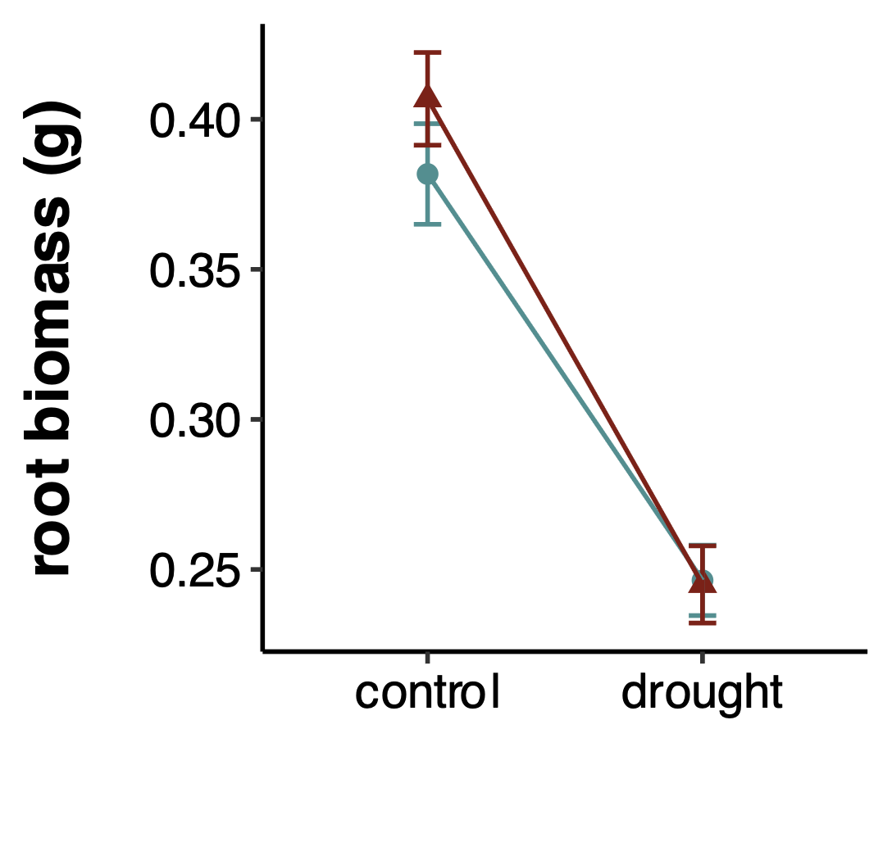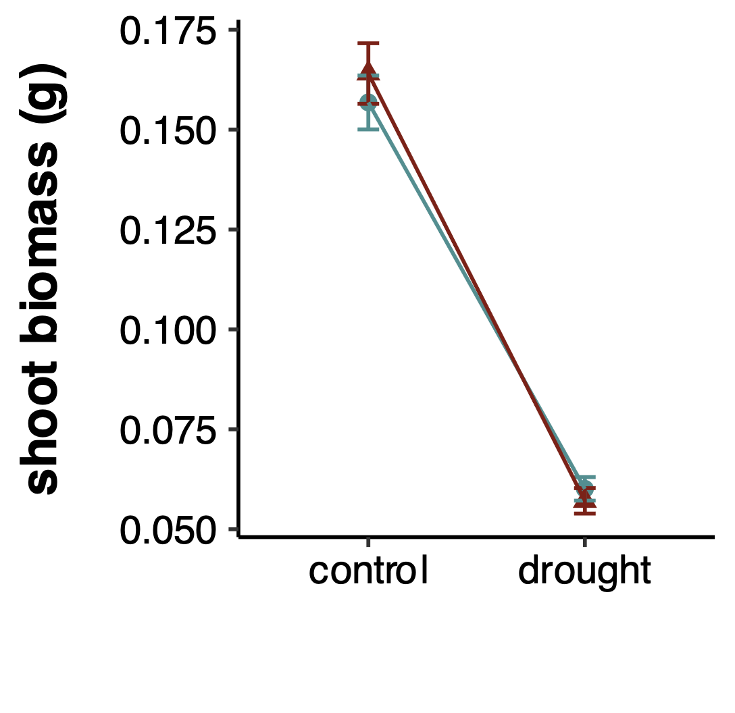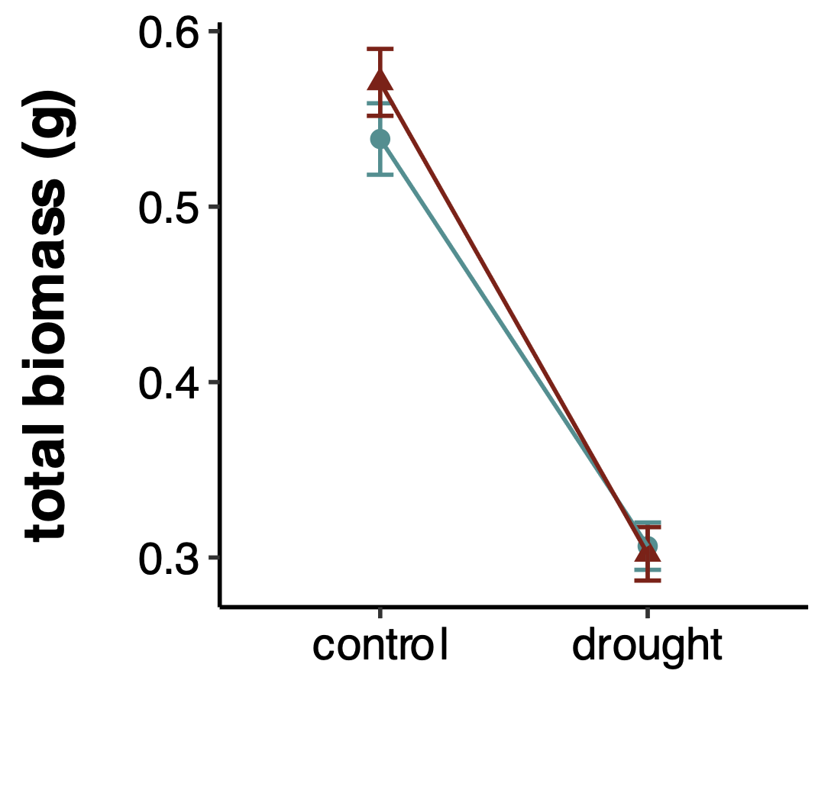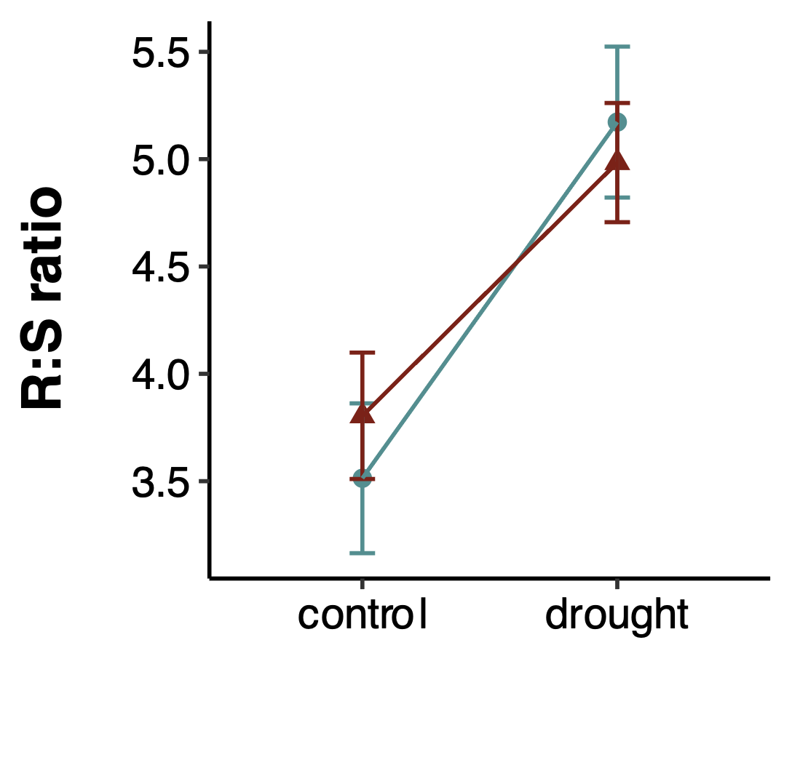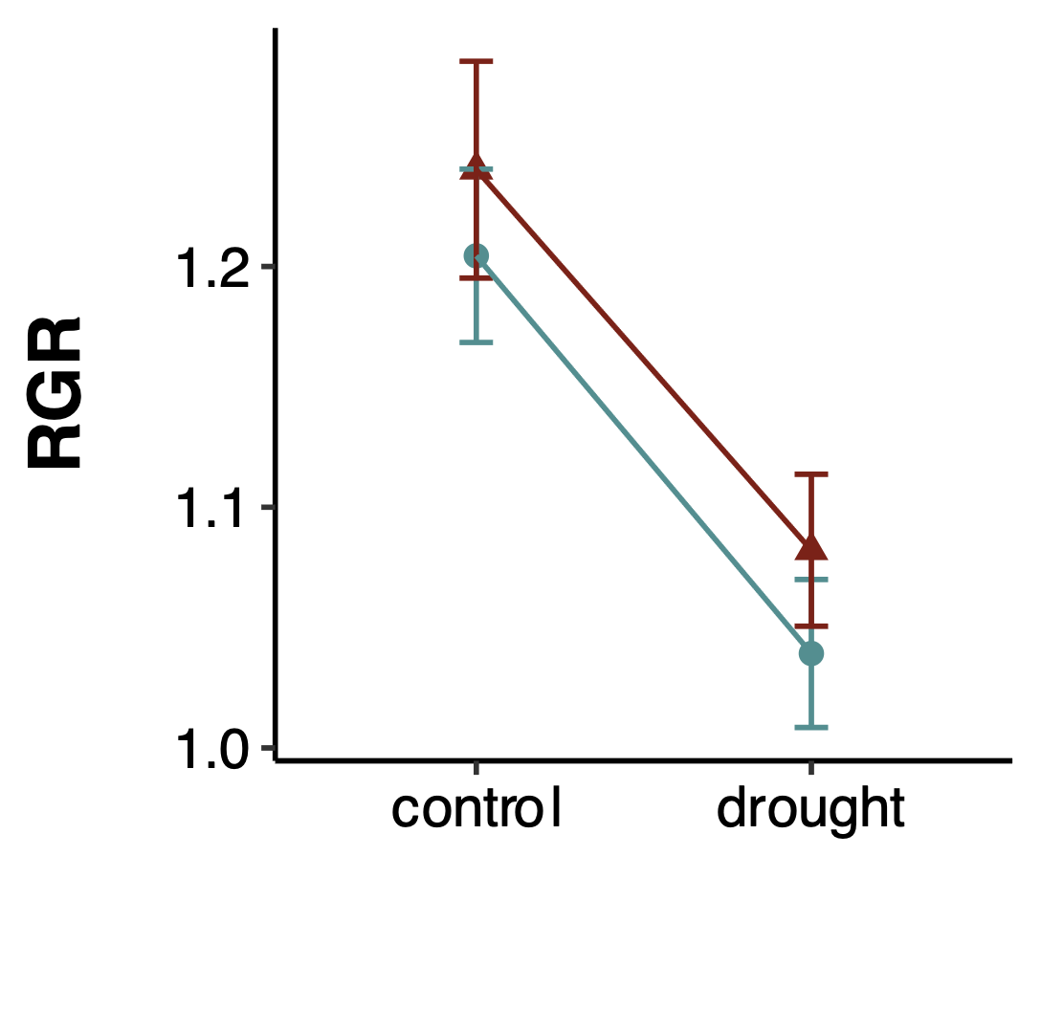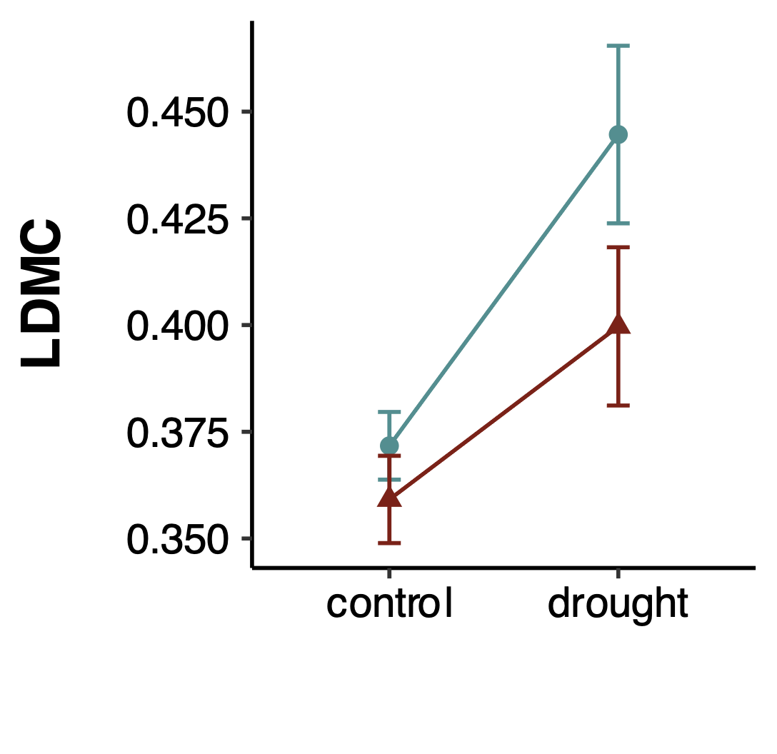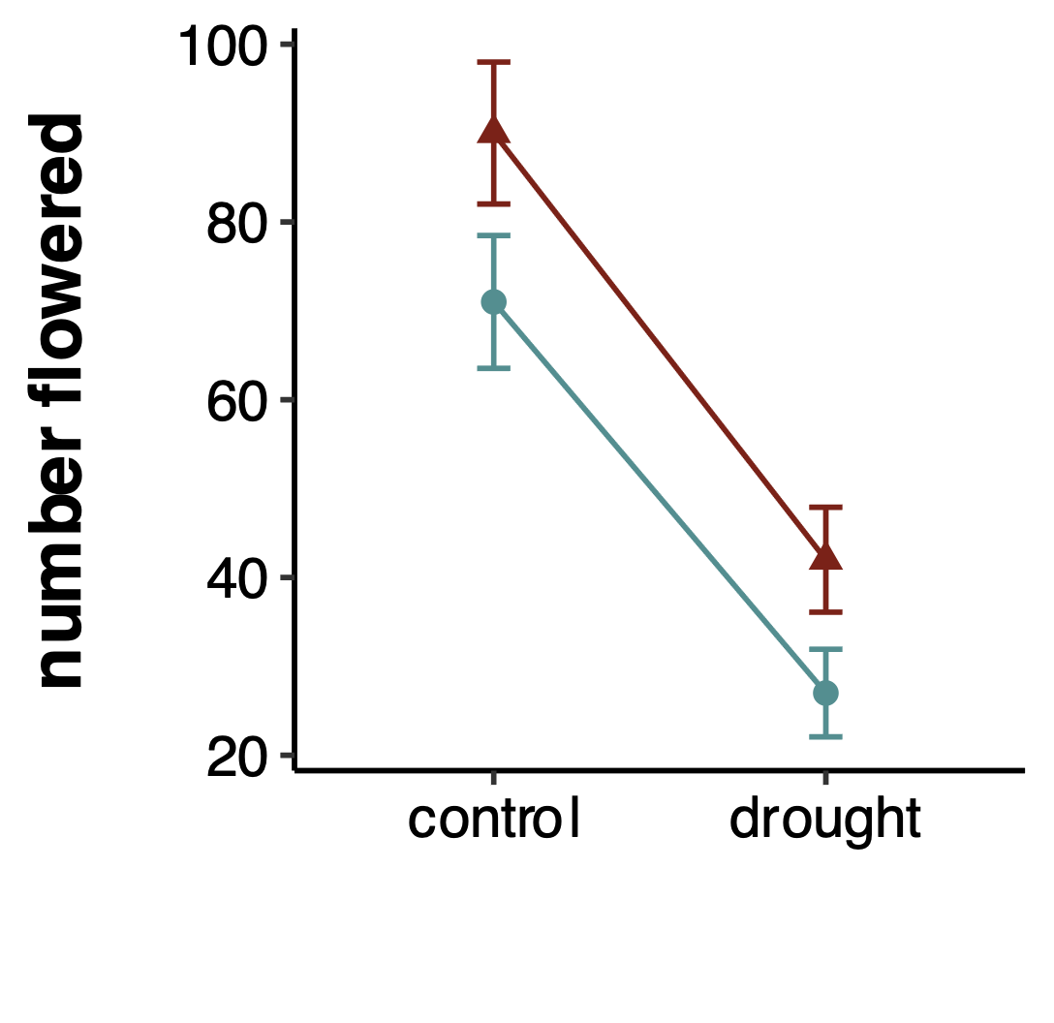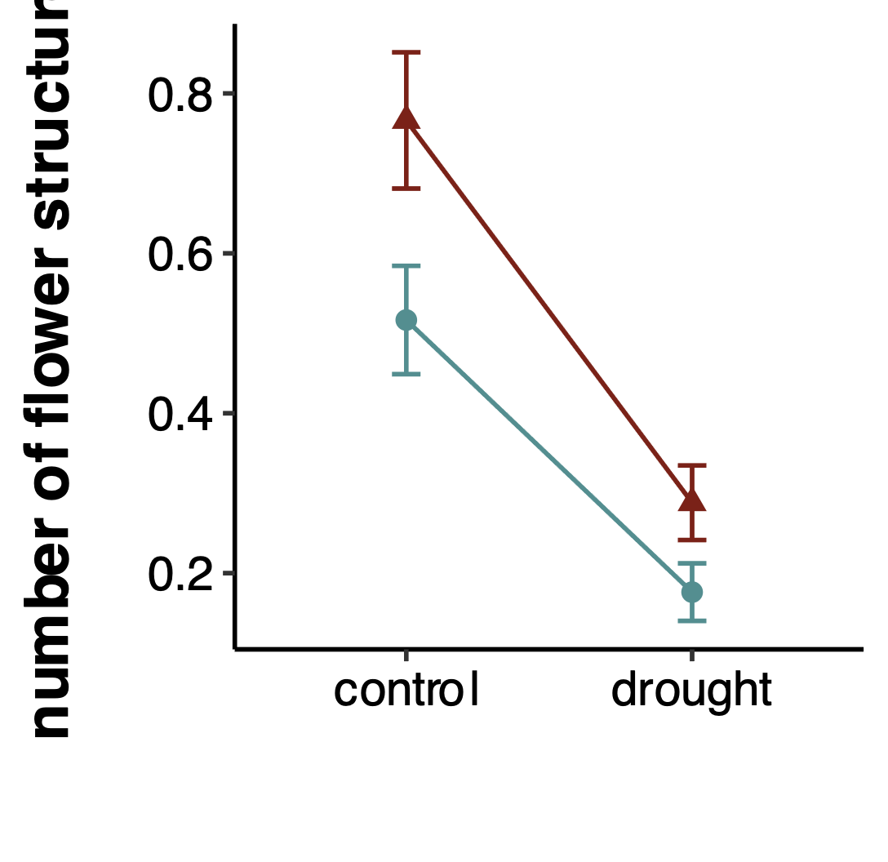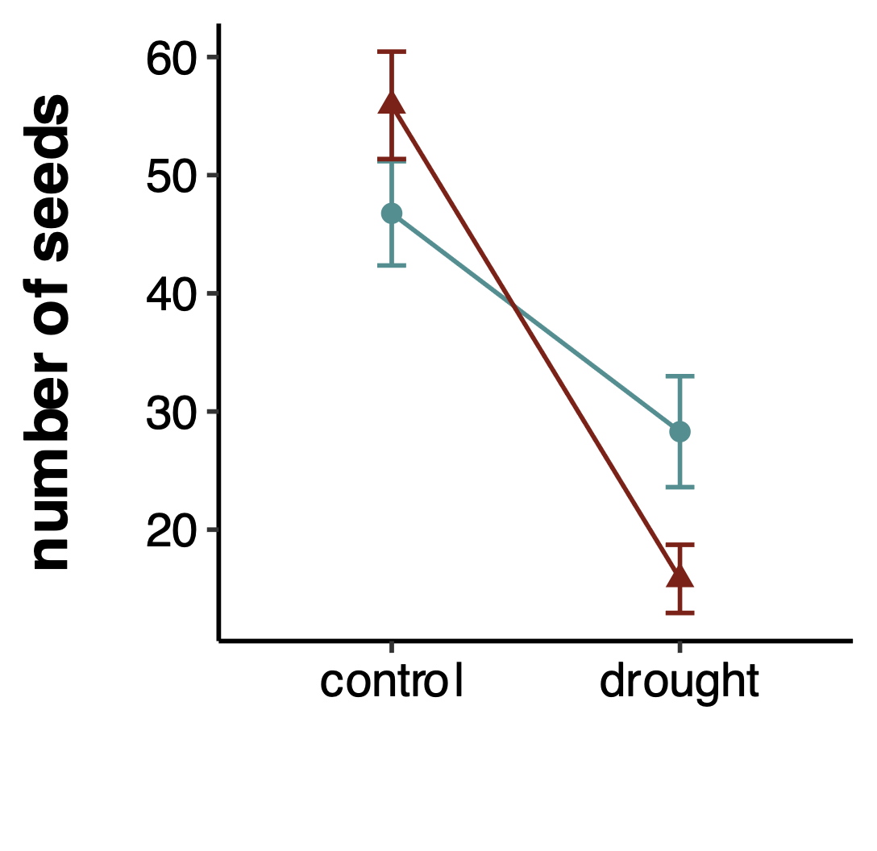

**a)**

**b)**

**c)**

**d)**

**e)**

**f)**

**g)**

**h)**

**i)**

**OT: \*\*\***

PT: ns

OT x PT: ns

**OT: \*\*\***

PT: ns

OT x PT: ns

**OT: \*\*\***

PT: ns

OT x PT: ns

**OT: \*\*\***

PT: ns

OT x PT: ns

**OT: \*\*\***

PT: ns

OT x PT: ns

**OT: \*\***

PT: ns

OT x PT: ns

**OT: \*\***

**PT: \*\***

OT x PT: ns

**OT: \*\*\***

PT: ns

OT x PT: ns

**OT: \***

PT: ns

**OT x PT: \*\***

**parental treatment**

control

drought

**offspring treatment**

**offspring treatment**

**offspring treatment**

**Figure 4.** Effects of transgenerational plasticity across all eleven populations of *P. patagonica* on number of seeds produced. Letters mark significant differences between each treatment cohort (DD = F1 dry / F2 dry, DC = F1 dry / F2 control, CD = F1 control / F2 dry, and CC = F1 control / F2 control). Error bars represent SE.

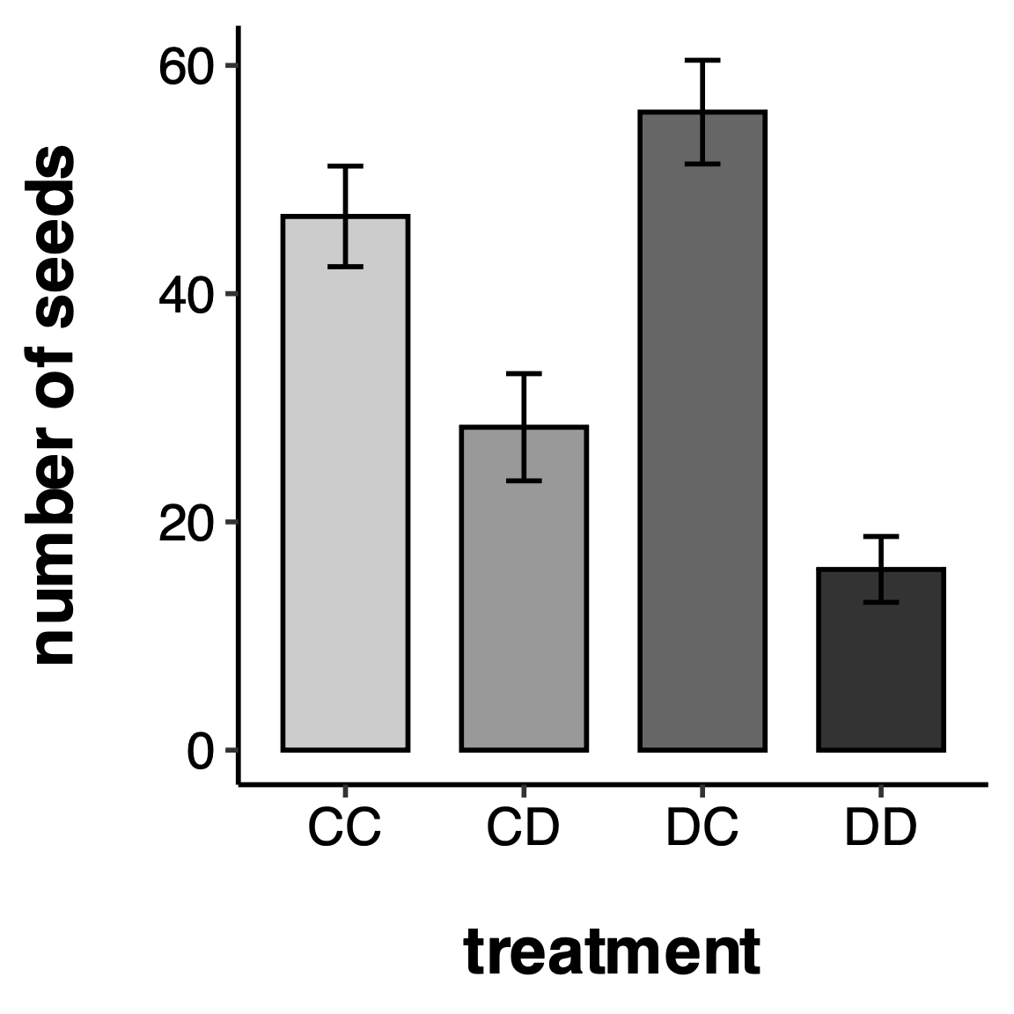

**a**

**a**

**b**

**c**

**Table 2**. Results of mixed models testing the effects of offspring watering treatment (OT), parental watering treatment (PT), and seed source climate at origin value: the 30-year mean annual spring VPDmax (kPa) coefficient of variation for each seed source location, and their interactions. P values = 0.05 < *#p* < 0.1; \*p < 0.05; \*\*p < 0.01; \*\*\*p < 0.001. F-statistic (linear models) or Chi-squared statistic (generalized linear models), signiﬁcance levels and degrees of freedom (d.f.) are shown for each term. Zero inflated models were used for number flowered and number of flowering structures produced per plant. Population was included as a random factor. R2m = marginal R2; R2c = conditional R2.

*\*The conditional R2 could not be calculated because the random effect variance for (1|pop) was effectively zero, suggesting minimal variation in population-level differences. The random effect was retained in the model due to its conceptual importance.*

|  |  |  |  |  |  |  |  |  |  |
| --- | --- | --- | --- | --- | --- | --- | --- | --- | --- |
| trait | OT | PT | sVPD-CV | OT x PT | OT x sVPD-CV | PT x sVPD-CV | OT x PT x sVPD-CV | R2m | R2c |
| **GROWTH** |  |  |  |  |  |  |  |  |  |
| root biomass | **F = 42.1948\*\*\*** | *F = 3.1251 #* | F = 2.0861 | F = 1.0453 | **F = 6.6818\*\*** | **F = 6.4877\*** | **F = 6.9657\*\*** | 0.141 | 0.175 |
| shoot biomass | **F = 184.3293\*\*\*** | F = 0.8007 | **F = 8.7548\*\*** | F = 0.3128 | **F = 4.0071\*** | *F = 3.8151 #* | F = 0.909 | 0.345 | 0.433 |
| total biomass | **F = 92.9724\*\*\*** | *F = 3.3317 #* | F = 0.0065 | F = 1.0925 | F = 2.3834 | F = 2.2751 | *F = 3.6949 #* | 0.234 | 0.293 |
| max height | F = 1.9401 | F = 0.0358 | F = 0.5302 | F = 1.0994 | F = 0.0117 | **F = 5.6204\*** | F = 0.3554 | 0.009 | 0.147 |
| **RESOURCE ALLOCATION** |  |  |  |  |  |  |  |  |  |
| R:S ratio | **F = 38.6267\*\*\*** | F = 2.6923 | **F = 8.6016\*\*** | F = 0.8986 | **F = 6.3966\*** | F = 2.5964 | *F = 3.4765 #* | 0.101 | 0.147 |
| RGR | **F = 12.7805\*\*\*** | F = 0.0007 | F = 0.0786 | F = 0.3424 | F = 0.7966 | F = 0.5182 | **F = 5.8834\*** | 0.025 | 0.069 |
| SLA | F = 1.8832 | F = 0.4492 | F = 0.111 | F = 0.1753 | F = 0.2841 | F = 2.0341 | F = 0.1777 | 0.016 | 0.084 |
| LDMC | **F = 8.1292\*\*** | F = 1.2131 | F = 0.0856 | F = 0.5561 | F = 0.0461 | F = 0.0098 | F = 0.2471 | 0.031 | 0.071 |
| **SURVIVAL** |  |  |  |  |  |  |  |  |  |
| mortality | X2 = 1.5818 | X2 = 1.9809 | X2 = 0.5622 | X2 = 0.3407 | X2 = 0.1891 | *X2 = 3.7915 #* | X2 = 0.2526 | 0.026 | 0.053 |
| **REPRODUCTION** |  |  |  |  |  |  |  |  |  |
| days to flowering | X2 = 2.4899 | X2 = 1.1826 | X2 = 0.4963 | X2 = 0.2623 | X2 = 0.8655 | X2 = 0.0651 | X2 = 0.864 | 0.058 | 0.120 |
| number flowered |  |  |  |  |  |  |  |  |  |
| *conditional model* | **X2 = 7.2036\*\*** | **X2 = 10.0314\*\*** | X2 = 0.7833 | X2 = 0.3388 | X2 = 0.3699 | **X2 = 9.7222\*\*** | *X2 = 2.9813 #* | 0.263 | 0.596 |
| *zero-inflation model* | X2 = 0.0247 | X2 = 0.575 | **X2 = 16.8902\*\*\*** |  |  |  |  |  |  |
| number of flowering structures |  |  |  |  |  |  |  |  |  |
| *conditional model* | X2 = 0.8824 | *X2 = 3.3255 #* | **X2 = 6.1195\*** | X2 = 2.0336 | X2 = 1.1482 | *X2 = 2.8731 #* | X2 = 1.2142 | 0.305 | 0.000\* |
| *zero-inflation model* | **X2 = 23.078\*\*\*** | **X2 = 10.632\*\*** | **X2 = 15.949\*\*\*** |  |  |  |  |  |  |
| seed number | **X2 = 3.8636\*** | X2 = 1.879 | X2 = 0.0613 | **X2 = 5.2154\*** | X2 = 0.0259 | X2 = 0.2191 | X2 = 0.6711 | 0.270 | 0.270 |
| df | 1 | 1 | 1 | 1 | 1 | 1 | 1 |  |  |

**Figure 4**. Effects of spring VPD CV of seed source origin and plasticity treatment on a) root biomass and b) RGR, traits where the response of the offspring to OT and PT was modulated by seed source spring VPD CV (OT x PT x sVPD-CV = significant). Grey areas represent SE.

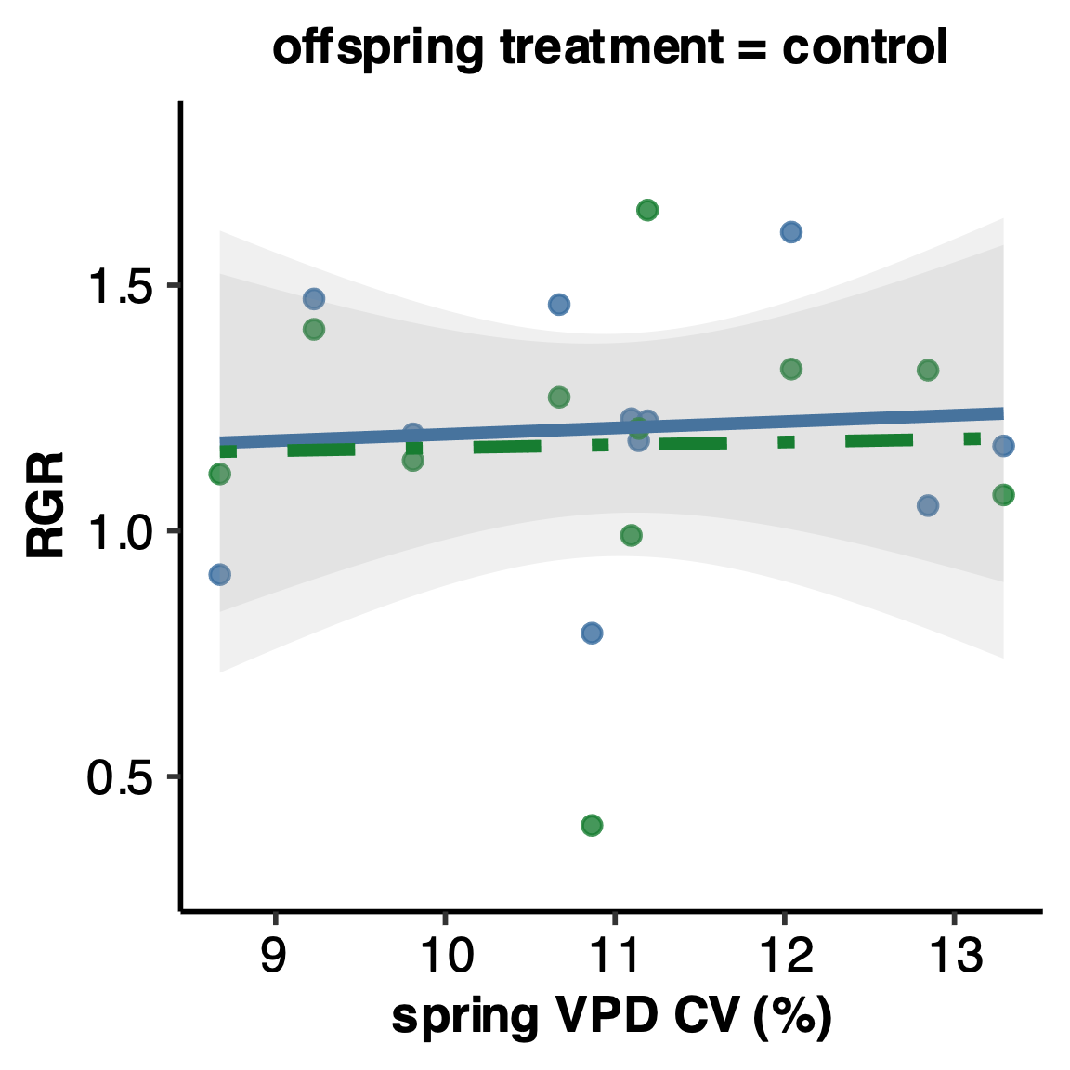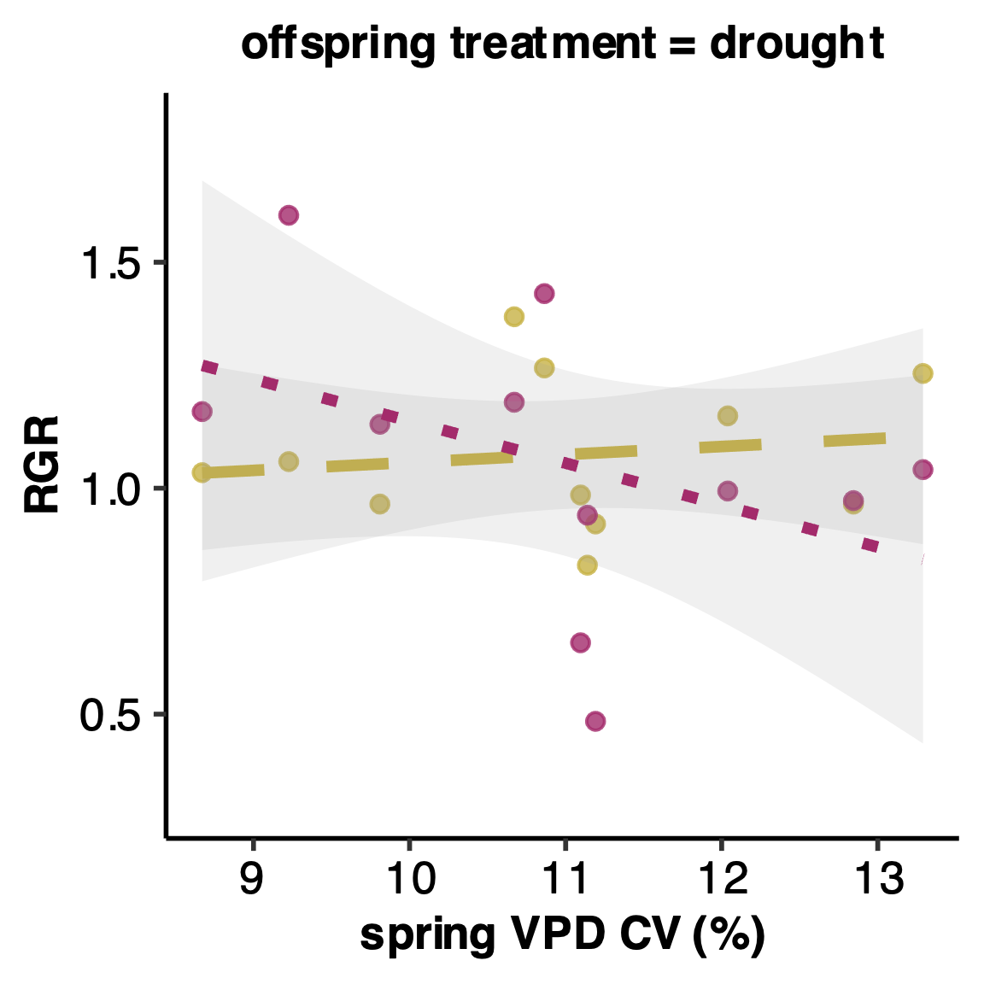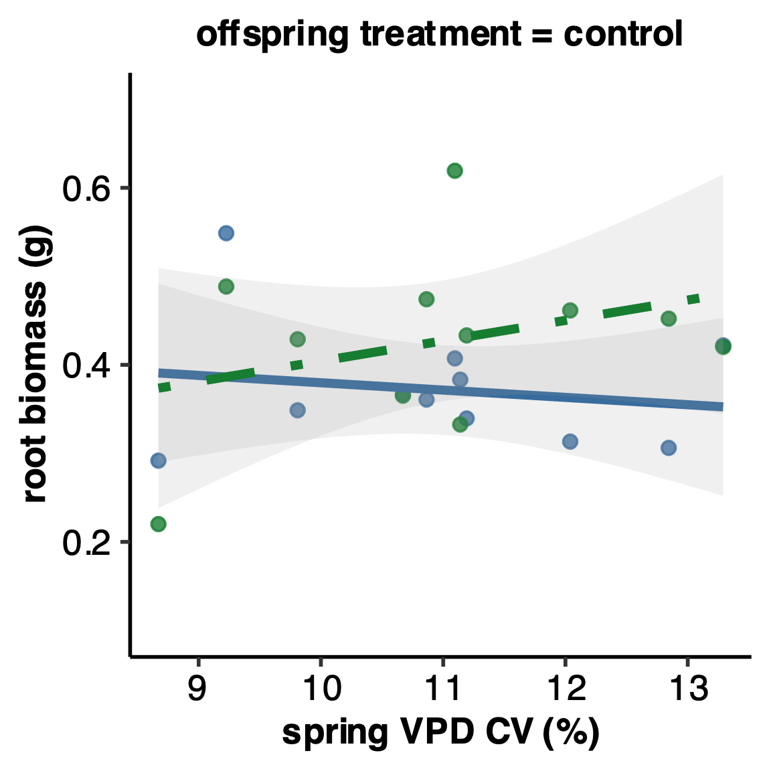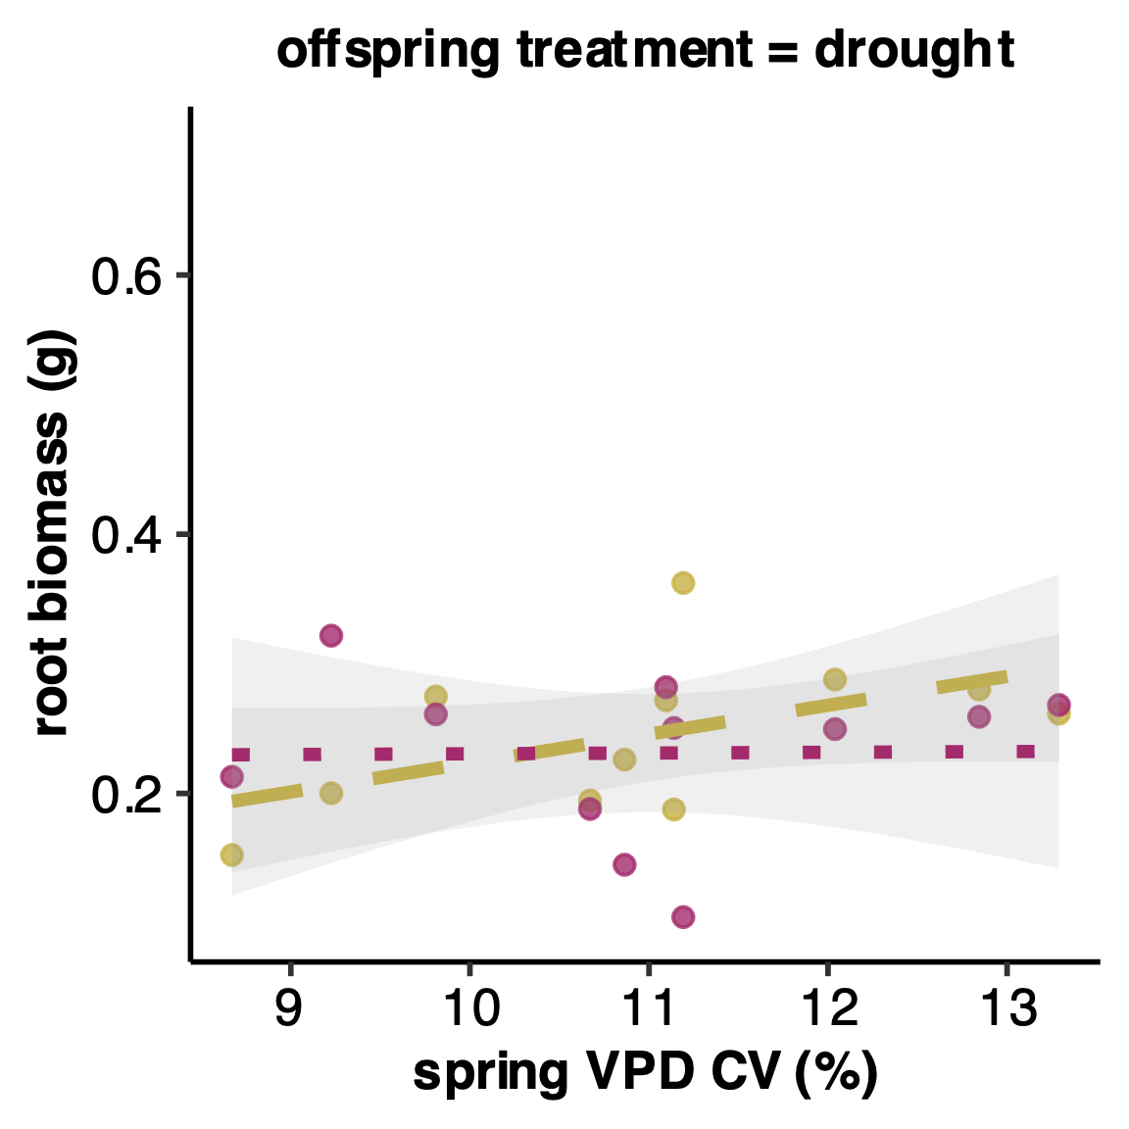

**a)**

**b)**

**CC**

**DC**

**CD**

**DD**

**Table 3**. Results of linear regressions testing for relationships between fitness traits and transgenerational RDPI (CC-DD) of a) performance traits and b) home site spring VPD CV. Shown are the R2-values. P values = p. < 0.1; \*p < 0.05; \*\*p < 0.01; \*\*\*p < 0.001. Signiﬁcant terms are shown in bold; terms in italics are marginally signiﬁcant.

|  |  |  |  |  |
| --- | --- | --- | --- | --- |
|  | **a)** seed number | mortality rate | flowering rate | **b)** spring VPD CV |
| RGR | -0.0604 | **-0.129\*\*** | 0.007 | -0.034 |
| root biomass | 0.105 | -0.051 | **0.336\*\*\*** | **-0.292\*\*\*** |

**Figure 5.** Relationship between RGR plasticity (RDPI of CC-DD) and a) proportion alive, b) proportion flowered, and c) spring VPD CV for eleven populations of *P. patagonica*. Proportion alive was measured on day 50. Grey areas indicate 95% confidence intervals.

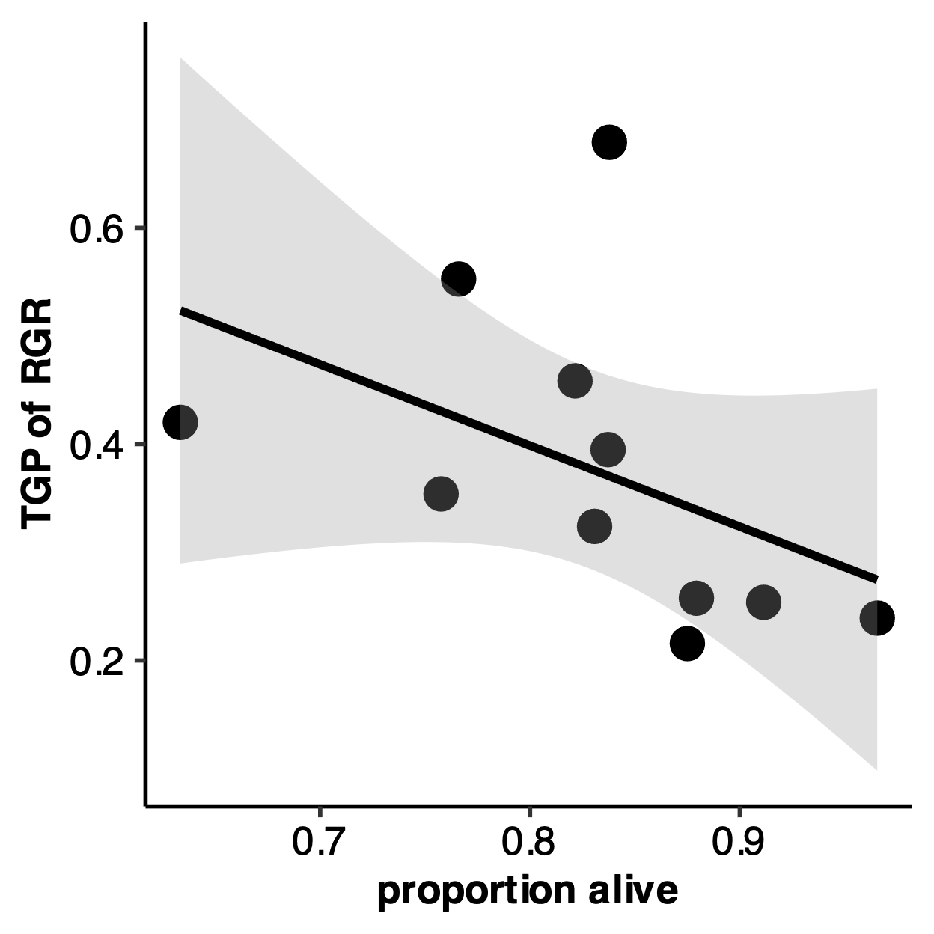

R = 0.111 , P = 0.0079

**a)**

R = -0.129, P = 0.0021

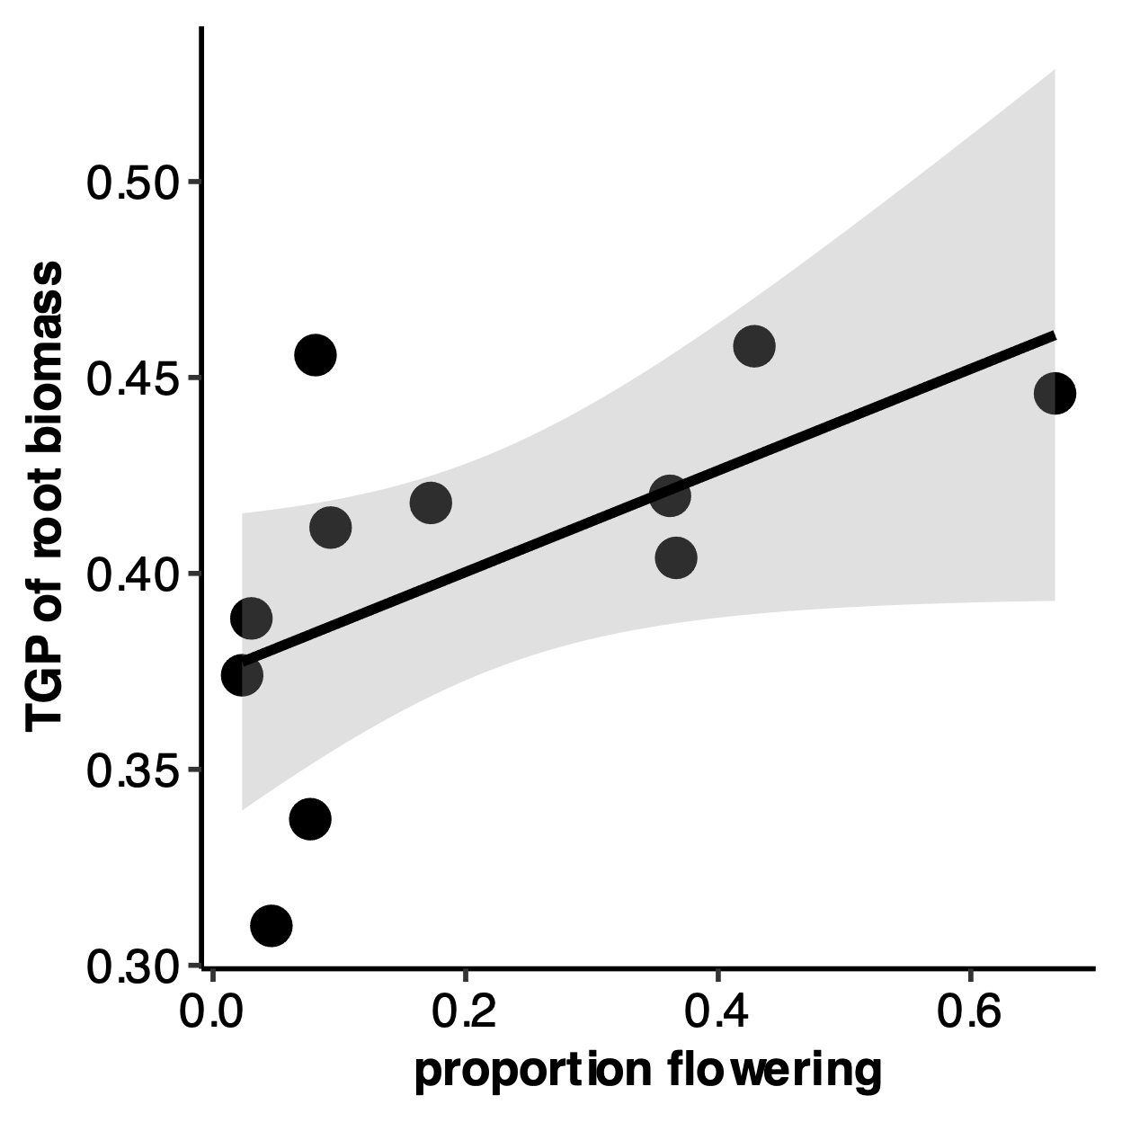

**b)**

R = 0.336, P = 2.2E-16

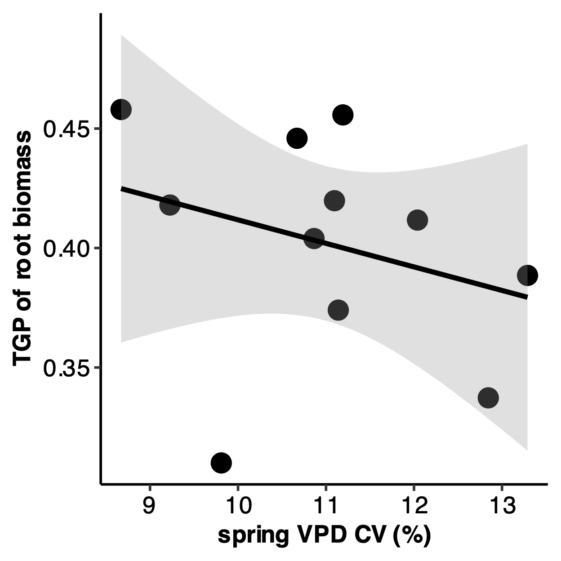

**c)**

R = -0.292, P = 2.2E-16

## Discussion

As climate change rapidly progresses, elevated aridity is an increasingly common phenomenon and can have profound consequence for the stability of plant populations and communities. To predict and manage biodiversity, it is critical to understand the mechanisms that generate resilience to climate change. Transgenerational plasticity may be one mechanism by which species can withstand rapidly changing environments (Herman & Sultan, 2011) and could be leveraged for restoration and revegetation in the face of change. Here, we used 11 populations of *Plantago patagonica* sourced across a gradient of spring VPD variability and exposed them to a fully factorial, multi-generation water limitation experiment, to ask: 1) Is there evidence of TGP in response to water limitation in *P. patagonica*? 2) Does collection site climate variability predict the magnitude of the TGP response to water limitation? and 3) Is TGP response to water limitation adaptive?

We found evidence of transgenerational plasticity in *P. patagonica* that suggests water limitation over multiple generations has significant negative effects on the reproductive output regardless of home site climate (Figure 3I). Additionally, we found that home site variability modulates transgenerational responses in traits related to growth and resource allocation (Figure 4), but not in reproductive traits (Table 2). Overall, *P. patagonica* only expressed a small of amount of transgenerational plasticity. Most of the trait plasticity occurred in response to offspring water limitations. Below, we discuss each of these results, the mechanisms that may have given rise to these patterns, and their implications.

***Maladaptive transgenerational plasticity in P. patagonica***

When plants were exposed to water limitations in the offspring generation, plants that also experienced water limitation in the parental generation (DD) produced fewer seeds than offspring of well-watered plants (CD) (Figure 4; Table 2). This finding suggests that TGP may not be an adaptive strategy when exposed to multiple generations of drought—in fact, this suggests that multiple generations of water limitation may induce maladaptive TGP in *P. patagonica,* even in populations sourced from climates where conditions change across generations, as evidenced by the lack of significance in the OT x PT x sVPD CV interaction (Table 3, (Kuijper & Hoyle, 2015)). Seed number is one of the best surrogates of lifetime fitness in annual plants. Back-to-back generations exposed to water limitation may limit the fitness of offspring, decreasing their ability to compete and spread, suggesting that we may see future population declines in areas that are experiencing winter and spring drought conditions more frequently. This reduction in number of seeds produced under multiple generations of water limitation has been observed in a few other studies, including *Amaranthus albus* in (Fenesi et al., 2014). In contrast to our findings, most TGP studies observe an increase (*Secale sylvestre*, (Mojzes et al., 2021)) or no effect (*Helianthemum squamatum* and *Centaurea hyssopifolia*, (Ramos-Muñoz et al., 2024)) on seed number in response to multiple generations of water limitation.

There were no other traits where matching parent-offspring environments had an effect or was beneficial across all eleven populations, indicating low levels of expression of TGP in *P. patagonica*. This contrasts with other TGP studies which found the expected pattern of matching parent-offspring environments producing adaptive transgenerational effects. These include effects of parental drought on total biomass and root systems of *Polygonum persicaria* (Sultan et al., 2009), root carbohydrate storage in *Plantago lanceolata* (Latzel et al., 2014), and shoot biomass and seed production in *Secale sylvestre* (Mojzes et al., 2021). There are several possible explanations for the absence of adaptive TGP in *P. patagonica*. Transgenerational conditioning of offspring requires the formation of complex mechanisms, including the perception and assessment of certain environmental signals, which may be difficult to perceive over the lifespan of a short lived annual. Additionally, transgenerational cues are passed down either epigenetically **(cite)** or through nutritive preparations of offspring **(cite)**. These complex mechanisms may have only evolved in some species, or in response to specific stresses. For example, no evidence of TGP was found in *Silene vulgaris* under three separate types of stress (Sandner et al., 2018), while adaptive TGP has only been found in one of two closely related *Polygonum* species (Sultan et al., 2009). Overall, our results suggest that that adaptive transgenerational plasticity may not be universal or easily leveraged phenomenon .

Another explanation for the absence of adaptive TGP in *P. patagonica* is its status as seed banking species (Haight et al., 2019). Influencing offspring phenotypes through adaptive TGP is one strategy an annual plant can use to increase fitness (Mousseau & Fox, 1998), and adaptive TGP usually occurs when parental and offspring environments are correlated (Burgess & Marshall, 2014; Leimar & McNamara, 2015). In contrast, plants may also evolve to produce heterogenous offspring phenotypes when the environment is inherently unpredictable, increasing the probability that at least some offspring phenotypes will match environmental conditions, a strategy known as diversified bet hedging (J. Marshall & Uller, 2007; Philippi & Seger, 1989; Simons, 2011; Slatkin, 1974). In arid environments, where water availability is uncertain, bet hedging via seed banking is a common strategy, especially in desert annuals (Golodets et al., 2013; Gremer & Venable, 2014; Venable & Brown, 1988). Seed banks spread germination out over time to reduce the likelihood of large population declines during unfavorable periods (Baskin & Baskin, 2000). By keeping a portion of seeds dormant in the seed bank, species incur less of a cost during climatically bad years (Philippi, 1993). Despite experimentally correlating parental and offspring environments, *P. patagonica* did not exhibit TGP in the traits we measured. However, in a study with *Biscutella didyma* and *Bromus fasciculatus*, two arid adapted winter annual species, Lampei et al. found that parental effects act on bet hedging traits (between-year seed dormancy) in *B. didyma*, but did not act on *B. fasciculatus’s* bet hedging traits, suggesting that bet hedging strategies and parental effects may synergize, but this effect is species dependent (Lampei et al., 2017). In future studies, *P. patagonica* may serve as a good candidate to further untangle the synergistic, antagonistic, or null effects of TGP on bet hedging strategies.

***Resource release in response to parental water limitations***

Interestingly, plants that experienced drought in the parental generation but control watering in the offspring generation (DC) had the highest performing reproductive traits of all the treatments (Figure 3G, H, and I). This is contrary to what we might expect, as transgenerational plasticity arises when the parental environment is correlated with the environment experienced by the offspring (Bonduriansky, 2021; Colicchio & Herman, 2020; J. Marshall & Uller, 2007; Uller, 2008). We observed the highest reproductive performance in plants that experienced a mismatch in parent and offspring environment, but only when drought occurred in the parental generation (DC), and not when drought occurred in the offspring generation (CD, higher reproductive performance than DD but far lower than control conditions).

This ‘release’ of resources in the DC group has also been seen in one other study, where grandparental and parental effects of mild heat stress were investigated in *Arabidopsis thaliana*. Groot et al. (2017) found when plants (F1) experienced mild heat stress, their offspring (F2) were prepared for the same stress, but when it was not applied, the plants shifted their resource load to overprovision their offspring. When comparing our results from the DC treatment, this suggests that drought exposure in the parental generation might act as an environmental trigger, preconditioning offspring to allocate resources in a way that enhances reproductive output. Both of these results align with a broader framework of phenotypic continuity across generations (as described by Badyaev & Uller, 2009), in which the offspring’s response is shaped not only by their immediate environment but also by environmental cues experienced by parent plants. This raises intriguing questions about how plants ‘anticipate’ environmental conditions across generations and allocate resources to maximize fitness based on parental, or grandparental, experiences.

***Within generation plasticity in P. patagonica***

We saw far higher rates of within-generation plasticity in P. patagonica (Table 1, Figure 3). This high degree of within generation plasticity is in line with other studies that imposed water limitations on multiple generations of annual plants (Germain et al., 2013; Kalandyk et al., 2017; Sultan et al., 2009). *Plantago patagonica* plants exposed to water limitation in the offspring generation were smaller in root, shoot, and total biomass, devoted more resources to roots than shoots, and had a slower relative growth rate and higher LDMC values, reflecting a more resource-conservative strategy when faced with limited water availability. This suggests that *P. patagonica* is highly sensitive to water stress and can express a high degree of plasticity to shift towards a more conservative strategy. Additionally, the results of this study serve to support the findings of Christie et al., who performed a resurrection study with 10 years of P. patagonica seeds from the Colorado Plateau to determine if it has rapidly evolved to 10 years of intense regional drought. Christie et al. found that descendent populations shifted their resource allocation, investing less in reproductive tissues and more in vegetative tissues (Christie et al., 2023).

***Some transgenerational responses are context-dependent on home site VPD variability***

Contrary to many TGP studies where plants have abundant genotype or population by environmental variation in inherited effects (Groot et al., 2017; Lampei et al., 2017; Li et al., 2017; Münzbergová & Hadincová, 2017), we found only two traits related to growth and resource allocation that changed based on home site spring VPD variability (Table 3, Figure 4). Here, plants from statistically variable environments (higher sVPD-CV) had higher root biomass if they experienced a mismatching of experimental treatment across the two generations (Figure 4A, right panel, DC vs. CC), indicating these populations may be more suited to dealing with environmental variability via shifts in biomass allocation toward water seeking tissues as a strategy to cope with unpredictable drought conditions.

Interestingly, plants that experienced two generations of water limitation had a decreasing relative growth rate as home site spring VPD variability increased (Figure 4B, left panel). These results align with theoretical and empirical work suggesting the adaptive value of TGP depends on the environmental predictability across generations (Badyaev & Uller, 2009; Colicchio & Herman, 2020; Leimar & McNamara, 2015). In relatively predictable climates (low sVPD CV). Parental drought exposure may prime offspring for similar stress in the offspring generation, resulting in higher relative growth rates. In more variable environments, where spring VPD conditions fluctuate more unpredictably across years, transgenerational signals may be unreliable or maladaptive, leading to reduced performance or more conservative growth strategies under water limitation. These results suggest that plants who experience two generations of water limitation (DD) and are sourced from a more variable climates have more resource conservative strategy, where water loss is limited at the cost of reduced carbon assimilation and growth, and likely, reproduction (survival > reproduction when RGR is low in annual plants). Alternatively, plants from less variable, more stable environments have a quicker RGR, and are therefore likely using a ‘drought-escape’ strategy (cite), where annual plants grow more quickly in drought conditions to reach the terminal reproductive stage.

***Relating performance plasticity, fitness, and home site VPD variability***

We found that RGR plasticity was negatively correlated with proportion of plants alive, indicating that under drought, as RGR plasticity decreases, survival increases. This suggests that individuals experiencing harsh environmental filters rapidly adjust their growth rate to best align with available resources, limiting the expression of maladaptive phenotypies, who are presumably lost via morality. Additionally, we found that higher plasticity in root biomass is associated with a higher proportion of plants that flower. Populations with greater plasticity in root biomass allocation are more likely to reach reproductive maturity; increased root plasticity might help individuals cope with varying water limitations, optimizing resource uptake to fuel allocation to flowering and reproduction.

Additionally, we found a weak but significant negative correlation between root biomass plasticity and home site sVPD CV, suggesting that variability in atmospheric drought year-to-year at seed source locations might be an important factor for the evolution of transgenerational plasticity (Figure 5D). Populations from sites with higher spring VPD CV showed reduced plasticity in their root biomass plasticity, aligning with the expectation that areas with higher variability over time reduces the chance of transgenerational plasticity arising, because environmental cues aren’t reliable indicators of the next year climate (Colicchio & Herman, 2020; Kuijper & Hoyle, 2015). In populations sourced from areas where variability is lower, and are more predictable year to year, plants displayed higher rates of transgenerational plasticity in their root biomass. Combining this finding with past work, where Klein & Mitchell found that *P. patagonica* populations sourced from sites with higher spring temperatures had higher within generation R:S plasticity, may suggest that seeds sourced from more physiologically stressful environments rely more on within generation plasticity, while seed sourced from more variable sites may rely more on transgenerational plasticity.

*Etc:*

Variations in the extent or nature of plasticity among populations indicate spatial differences in environmental variability across the landscape (Lind and Johansson 2007). The evolution of transgenerational versus within-generation plasticity depends on the temporal scale of environmental fluctuations, with transgenerational plasticity being more likely when conditions shift abruptly and predictably between generations (Kuijper and Hoyle 2015).

The drought treatment applied in this greenhouse experiment was applied early (7-10 days after germinating for most plants) and was very strong (50% reduction of water amount for the driest seed source location, so the water reduction was much higher for populations sourced from wetter areas).

Differences could be due to maternal provisioning, epigenetic effects that do not show plasticity, or genetic variation in drought tolerance. This could indicate maternal provisioning effects, genetic adaptation, or environmentally induced changes in seed traits (e.g., seed size, nutrient content, hormone levels) that persist regardless of the offspring environment. Parental effects rather than transgenerational effects, presumably epigenetic.

If maternal environmental effects were related to higher seed mass produced in optimum conditions, offspring of maternal plants grown under well-watered conditions should have higher fitness in both offspring treatments, a pattern not found in our study. Additionally, we found no difference in seed mass in seeds collected from the parental generation (Table S3). This suggests that rather than seed-provisioning, other mechanisms may be at play to induce transgenerational plasticity, such as methylation of DNA or changes in hormones. Further studies are needed to elucidate the mechanisms behind transgenerational responses.

## References

Badyaev, A. V., & Uller, T. (2009). Parental effects in ecology and evolution: Mechanisms, processes and implications. *Philosophical Transactions of the Royal Society B: Biological Sciences*, *364*(1520), 1169–1177. https://doi.org/10.1098/rstb.2008.0302

Barak, R. S., Fant, J. B., Kramer, A. T., & Skogen, K. A. (2015). Assessing the Value of Potential “Native Winners” for Restoration of Cheatgrass-Invaded Habitat. *Western North American Naturalist*, *75*(1), 58–69. https://doi.org/10.3398/064.075.0107

Bartlett, M. K., Scoffoni, C., & Sack, L. (2012). The determinants of leaf turgor loss point and prediction of drought tolerance of species and biomes: A global meta-analysis. *Ecology Letters*, *15*(5), 393–405. https://doi.org/10.1111/j.1461-0248.2012.01751.x

Baskin, C. C., & Baskin, J. M. (2000). *Seeds: Ecology, Biogeography, and, Evolution of Dormancy and Germination*. Academic Press.

Bell, A. M., & Hellmann, J. K. (2019). An Integrative Framework for Understanding the Mechanisms and Multigenerational Consequences of Transgenerational Plasticity. *Annual Review of Ecology, Evolution, and Systematics*, *50*(Volume 50, 2019), 97–118. https://doi.org/10.1146/annurev-ecolsys-110218-024613

Bonduriansky, R. (2021). Plasticity Across Generations. In *Phenotypic Plasticity & Evolution*. CRC Press. https://doi.org/10.1201/9780429343001

Burgess, S. C., & Marshall, D. J. (2014). Adaptive parental effects: The importance of estimating environmental predictability and offspring fitness appropriately. *Oikos*, *123*(7), 769–776. https://doi.org/10.1111/oik.01235

Christie, K., Pierson, N. R., Holeski, L. M., & Lowry, D. B. (2023). Resurrected seeds from herbarium specimens reveal rapid evolution of drought resistance in a selfing annual. *American Journal of Botany*, *110*(12), e16265. https://doi.org/10.1002/ajb2.16265

Colicchio, J. M., & Herman, J. (2020). Empirical patterns of environmental variation favor adaptive transgenerational plasticity. *Ecology and Evolution*, *10*(3), 1648–1665. https://doi.org/10.1002/ece3.6022

Cornwell, W. K., & Ackerly, D. D. (2009). Community assembly and shifts in plant trait distributions across an environmental gradient in coastal California. *Ecological Monographs*, *79*(1), 109–126. https://doi.org/10.1890/07-1134.1

Crawley, M. J. (2009). *Plant Ecology*. John Wiley & Sons.

Dai, A. (2011). Drought under global warming: A review. *WIREs Climate Change*, *2*(1), 45–65. https://doi.org/10.1002/wcc.81

Donelson, J. M., Salinas, S., Munday, P. L., & Shama, L. N. S. (2018). Transgenerational plasticity and climate change experiments: Where do we go from here? *Global Change Biology*, *24*(1), 13–34. https://doi.org/10.1111/gcb.13903

Engqvist, L., & Reinhold, K. (2016). Adaptive trans-generational phenotypic plasticity and the lack of an experimental control in reciprocal match/mismatch experiments. *Methods in Ecology and Evolution*, *7*(12), 1482–1488. https://doi.org/10.1111/2041-210X.12618

Fenesi, A., Dyer, A. R., Geréd, J., Sándor, D., & Ruprecht, E. (2014). Can transgenerational plasticity contribute to the invasion success of annual plant species? *Oecologia*, *176*(1), 95–106. https://doi.org/10.1007/s00442-014-2994-7

Fischer, B., Taborsky, B., & Kokko, H. (2011). How to balance the offspring quality–quantity tradeoff when environmental cues are unreliable. *Oikos*, *120*(2), 258–270. https://doi.org/10.1111/j.1600-0706.2010.18642.x

Galloway, L. F. (2001). Parental Environmental Effects on Life History in the Herbaceous Plant Campanula Americana. *Ecology*, *82*(10), 2781–2789. https://doi.org/10.1890/0012-9658(2001)082[2781:PEEOLH]2.0.CO;2

Germain, R. M., Caruso, C. M., & Maherali, H. (2013). Mechanisms and Consequences of Water Stress–Induced Parental Effects in an Invasive Annual Grass. *International Journal of Plant Sciences*, *174*(6), 886–895. https://doi.org/10.1086/670691

Golodets, C., Sternberg, M., Kigel, J., Boeken, B., Henkin, Z., Seligman, N. G., & Ungar, E. D. (2013). From desert to Mediterranean rangelands: Will increasing drought and inter-annual rainfall variability affect herbaceous annual primary productivity? *Climatic Change*, *119*(3), 785–798. https://doi.org/10.1007/s10584-013-0758-8

Gremer, J. R., & Venable, D. L. (2014). Bet hedging in desert winter annual plants: Optimal germination strategies in a variable environment. *Ecology Letters*, *17*(3), 380–387. https://doi.org/10.1111/ele.12241

Groot, M. P., Kubisch, A., Ouborg, N. J., Pagel, J., Schmid, K. J., Vergeer, P., & Lampei, C. (2017). Transgenerational effects of mild heat in Arabidopsis thaliana show strong genotype specificity that is explained by climate at origin. *New Phytologist*, *215*(3), 1221–1234. https://doi.org/10.1111/nph.14642

Haight, J. D., Reed, S. C., & Faist, A. M. (2019). Seed bank community and soil texture relationships in a cold desert. *Journal of Arid Environments*, *164*, 46–52. https://doi.org/10.1016/j.jaridenv.2019.01.008

Herman, J., & Sultan, S. (2011). Adaptive Transgenerational Plasticity in Plants: Case Studies, Mechanisms, and Implications for Natural Populations. *Frontiers in Plant Science*, *2*(102). https://doi.org/10.3389/fpls.2011.00102

Hoffmann, A. A., & Sgrò, C. M. (2011). Climate change and evolutionary adaptation. *Nature*, *470*(7335), Article 7335. https://doi.org/10.1038/nature09670

Holeski, L. M. (2007). Within and between generation phenotypic plasticity in trichome density of Mimulus guttatus. *Journal of Evolutionary Biology*, *20*(6), 2092–2100. https://doi.org/10.1111/j.1420-9101.2007.01434.x

Holeski, L. M., Jander, G., & Agrawal, A. A. (2012). Transgenerational defense induction and epigenetic inheritance in plants. *Trends in Ecology & Evolution*, *27*(11), 618–626. https://doi.org/10.1016/j.tree.2012.07.011

Hoyle, R. B., & Ezard, T. H. G. (2012). The benefits of maternal effects in novel and in stable environments. *Journal of The Royal Society Interface*, *9*(75), 2403–2413. https://doi.org/10.1098/rsif.2012.0183

J. Marshall, D., & Uller, T. (2007). When is a maternal effect adaptive? *Oikos*, *116*(12), 1957–1963. https://doi.org/10.1111/j.2007.0030-1299.16203.x

Kalandyk, A., Waligórski, P., & Dubert, F. (2017). Role of the maternal effect phenomena in improving water stress tolerance in narrow-leafed lupine (upinus angustifolius). *Plant Breeding*, *136*(2), 167–173. https://doi.org/10.1111/pbr.12457

Klein, Z., & Mitchell, R. M. (2023). Seed source environment predicts response to water availability in *Plantago patagonica*. *Restoration Ecology*, 1–11. https://doi.org/10.1111/rec.14002

Kuijper, B., & Hoyle, R. B. (2015). When to rely on maternal effects and when on phenotypic plasticity? *Evolution; International Journal of Organic Evolution*, *69*(4), 950–968. https://doi.org/10.1111/evo.12635

Lampei, C., Metz, J., & Tielbörger, K. (2017). Clinal population divergence in an adaptive parental environmental effect that adjusts seed banking. *New Phytologist*, *214*(3), 1230–1244. https://doi.org/10.1111/nph.14436

Latzel, V., Fischer, M., Groot, M., Gutzat, R., Lampei, C., Ouborg, J., Parepa, M., Schmid, K., Vergeer, P., Zhang, Y., & Bossdorf, O. (2023). Parental environmental effects are common and strong, but unpredictable, in Arabidopsis thaliana. *New Phytologist*, *237*(3), 1014–1023. https://doi.org/10.1111/nph.18591

Latzel, V., Janeček, Š., Doležal, J., Klimešová, J., & Bossdorf, O. (2014). Adaptive transgenerational plasticity in the perennial *Plantago lanceolata*. *Oikos*, *123*(1), 41–46. https://doi.org/10.1111/j.1600-0706.2013.00537.x

Leimar, O., & McNamara, J. M. (2015). The Evolution of Transgenerational Integration of Information in Heterogeneous Environments. *The American Naturalist*, *185*(3), E55–E69. https://doi.org/10.1086/679575

Li, R., Chen, L., Wu, Y., Zhang, R., Baskin, C. C., Baskin, J. M., & Hu, X. (2017). Effects of Cultivar and Maternal Environment on Seed Quality in Vicia sativa. *Frontiers in Plant Science*, *8*, 1411. https://doi.org/10.3389/fpls.2017.01411

Louthan, A. M., Doak, D. F., & Angert, A. L. (2015). Where and When do Species Interactions Set Range Limits? *Trends in Ecology & Evolution*, *30*(12), 780–792. https://doi.org/10.1016/j.tree.2015.09.011

Matesanz, S., Ramos-Muñoz, M., Rubio Teso, M. L., & Iriondo, J. M. (2022). Effects of parental drought on offspring fitness vary among populations of a crop wild relative. *Proceedings of the Royal Society B: Biological Sciences*, *289*(1981), 20220065. https://doi.org/10.1098/rspb.2022.0065

Midolo, G., & Wellstein, C. (2020). Plant performance and survival across transplant experiments depend upon temperature and precipitation change along elevation. *Journal of Ecology*, *108*(5), 2107–2120. https://doi.org/10.1111/1365-2745.13387

Mojzes, A., Kalapos, T., & Kröel‑Dulay, G. (2021). Drought in maternal environment boosts offspring performance in a subordinate annual grass. *Environmental and Experimental Botany*, *187*, 104472. https://doi.org/10.1016/j.envexpbot.2021.104472

Mousseau, T. A., & Fox, C. W. (1998). *Maternal Effects As Adaptations*. Oxford University Press.

Münzbergová, Z., & Hadincová, V. (2017). Transgenerational plasticity as an important mechanism affecting response of clonal species to changing climate. *Ecology and Evolution*, *7*(14), 5236–5247. https://doi.org/10.1002/ece3.3105

Nicotra, A. B., Atkin, O. K., Bonser, S. P., Davidson, A. M., Finnegan, E. J., Mathesius, U., Poot, P., Purugganan, M. D., Richards, C. L., Valladares, F., & van Kleunen, M. (2010). Plant phenotypic plasticity in a changing climate. *Trends in Plant Science*, *15*(12), 684–692. https://doi.org/10.1016/j.tplants.2010.09.008

Philippi, T. (1993). Bet-Hedging Germination of Desert Annuals: Beyond the First Year. *The American Naturalist*, *142*(3), 474–487. https://doi.org/10.1086/285550

Philippi, T., & Seger, J. (1989). Hedging one’s evolutionary bets, revisited. *Trends in Ecology & Evolution*, *4*(2), 41–44. https://doi.org/10.1016/0169-5347(89)90138-9

Ramos-Muñoz, M., Blanco-Sánchez, M., Pías, B., Escudero, A., & Matesanz, S. (2024). Transgenerational plasticity to drought: Contrasting patterns of non-genetic inheritance in two semi-arid Mediterranean shrubs. *Annals of Botany*, *134*(1), 101–116. https://doi.org/10.1093/aob/mcae039

Räsänen, K., & Kruuk, L. E. B. (2007). Maternal effects and evolution at ecological time-scales. *Functional Ecology*, *21*(3), 408–421. https://doi.org/10.1111/j.1365-2435.2007.01246.x

Read, Q. D., Moorhead, L. C., Swenson, N. G., Bailey, J. K., & Sanders, N. J. (2014). Convergent effects of elevation on functional leaf traits within and among species. *Functional Ecology*, *28*(1), 37–45. https://doi.org/10.1111/1365-2435.12162

Reed, T. E., Waples, R. S., Schindler, D. E., Hard, J. J., & Kinnison, M. T. (2010). Phenotypic plasticity and population viability: The importance of environmental predictability. *Proceedings of the Royal Society B: Biological Sciences*, *277*(1699), 3391–3400. https://doi.org/10.1098/rspb.2010.0771

Riginos, C., Veblen, K. E., Thacker, E. T., Gunnell, K. L., & Monaco, T. A. (2023). Resilience and Resistance Framework Predicts Regional Vegetation Responses to Shrub Reduction Treatments in the Sagebrush Ecosystem. *Rangeland Ecology & Management*, *86*, 35–43. https://doi.org/10.1016/j.rama.2022.10.008

Sánchez-Tójar, A., Lagisz, M., Moran, N. P., Nakagawa, S., Noble, D. W. A., & Reinhold, K. (2020). The jury is still out regarding the generality of adaptive ‘transgenerational’ effects. *Ecology Letters*, *23*(11), 1715–1718. https://doi.org/10.1111/ele.13479

Sandner, T. M., van Braak, J. L., & Matthies, D. (2018). Transgenerational plasticity in Silene vulgaris in response to three types of stress. *Plant Biology*, *20*(4), 751–758. https://doi.org/10.1111/plb.12721

Sharma, N., Koul, P., & Koul, A. K. (1992). Reproductive Biology of Plantago: Shift from Cross- to Self-pollination. *Annals of Botany*, *69*(1), 7–11. https://doi.org/10.1093/oxfordjournals.aob.a088309

Simons, A. M. (2011). Modes of response to environmental change and the elusive empirical evidence for bet hedging. *Proceedings of the Royal Society B: Biological Sciences*, *278*(1712), 1601–1609. https://doi.org/10.1098/rspb.2011.0176

Slatkin, M. (1974). Hedging one’s evolutionary bets. *Nature*, *250*(5469), 704–705. https://doi.org/10.1038/250704b0

Song, Y., Zajic, C. J., Hwang, T., Hakkenberg, C. R., & Zhu, K. (2021). Widespread Mismatch Between Phenology and Climate in Human‐Dominated Landscapes. *AGU Advances*, *2*(4). https://doi.org/10.1029/2021AV000431

Spinoni, J., Barbosa, P., De Jager, A., McCormick, N., Naumann, G., Vogt, J. V., Magni, D., Masante, D., & Mazzeschi, M. (2019). A new global database of meteorological drought events from 1951 to 2016. *Journal of Hydrology: Regional Studies*, *22*, 100593. https://doi.org/10.1016/j.ejrh.2019.100593

Sultan, S. E. (1987). Evolutionary Implications of Phenotypic Plasticity in Plants. In M. K. Hecht, B. Wallace, & G. T. Prance (Eds.), *Evolutionary Biology* (pp. 127–178). Springer US. https://doi.org/10.1007/978-1-4615-6986-2\_7

Sultan, S. E., Barton, K., & Wilczek, A. M. (2009). Contrasting patterns of transgenerational plasticity in ecologically distinct congeners. *Ecology*, *90*(7), 1831–1839. https://doi.org/10.1890/08-1064.1

Uller, T. (2008). Developmental plasticity and the evolution of parental effects. *Trends in Ecology & Evolution*, *23*(8), 432–438. https://doi.org/10.1016/j.tree.2008.04.005

Uller, T., Nakagawa, S., & English, S. (2013). Weak evidence for anticipatory parental effects in plants and animals. *Journal of Evolutionary Biology*, *26*(10), 2161–2170. https://doi.org/10.1111/jeb.12212

Valladares, F., Sanchez-Gomez, D., & Zavala, M. A. (2006). Quantitative Estimation of Phenotypic Plasticity: Bridging the Gap between the Evolutionary Concept and Its Ecological Applications. *Journal of Ecology*, *94*(6), 1103–1116.

Venable, D. L., & Brown, J. S. (1988). The Selective Interactions of Dispersal, Dormancy, and Seed Size as Adaptations for Reducing Risk in Variable Environments. *The American Naturalist*, *131*(3), 360–384. https://doi.org/10.1086/284795

Wadgymar, S. M., Mactavish, R. M., & Anderson, J. T. (2018). Transgenerational and Within-Generation Plasticity in Response to Climate Change: Insights from a Manipulative Field Experiment across an Elevational Gradient. *The American Naturalist*, *192*(6), 698–714. https://doi.org/10.1086/700097

Westoby, M. (1998). A leaf-height-seed (LHS) plant ecology strategy scheme. *Plant and Soil*, *199*(2), 213–227. https://doi.org/10.1023/A:1004327224729

Wood, T. E., Doherty, K., & Padgett, W. (2015). Development of Native Plant Materials for Restoration and Rehabilitation of Colorado Plateau Ecosystems. *Natural Areas Journal*, *35*(1), 134–150. https://doi.org/10.3375/043.035.0117

Wright, I. J., Reich, P. B., Westoby, M., Ackerly, D. D., Baruch, Z., Bongers, F., Cavender-Bares, J., Chapin, T., Cornelissen, J. H. C., Diemer, M., Flexas, J., Garnier, E., Groom, P. K., Gulias, J., Hikosaka, K., Lamont, B. B., Lee, T., Lee, W., Lusk, C., … Villar, R. (2004). The worldwide leaf economics spectrum. *Nature*, *428*(6985), 821–827. https://doi.org/10.1038/nature02403

Yin, J., Zhou, M., Lin, Z., Li, Q. Q., & Zhang, Y.-Y. (2019). Transgenerational effects benefit offspring across diverse environments: A meta-analysis in plants and animals. *Ecology Letters*, *22*(11), 1976–1986. https://doi.org/10.1111/ele.13373

**References**

[Badyaev, A. V., & Uller, T. (2009). Parental effects in ecology and evolution: Mechanisms, processes and implications.](https://stuewe.com/" \t "_new) *[Philosophical Transactions of the Royal Society B: Biological Sciences](https://stuewe.com/" \t "_new)*[,](https://stuewe.com/" \t "_new) *[364](https://stuewe.com/" \t "_new)*[(1520), 1169–1177. https://doi.org/10.1098/rstb.2008.0302](https://stuewe.com/" \t "_new)

[Barak, R. S., Fant, J. B., Kramer, A. T., & Skogen, K. A. (2015). Assessing the Value of Potential “Native Winners” for Restoration of Cheatgrass-Invaded Habitat.](https://stuewe.com/" \t "_new) *[Western North American Naturalist](https://stuewe.com/" \t "_new)*[,](https://stuewe.com/" \t "_new) *[75](https://stuewe.com/" \t "_new)*[(1), 58–69. https://doi.org/10.3398/064.075.0107](https://stuewe.com/" \t "_new)

[Bartlett, M. K., Scoffoni, C., & Sack, L. (2012). The determinants of leaf turgor loss point and prediction of drought tolerance of species and biomes: A global meta-analysis.](https://stuewe.com/" \t "_new) *[Ecology Letters](https://stuewe.com/" \t "_new)*[,](https://stuewe.com/" \t "_new) *[15](https://stuewe.com/" \t "_new)*[(5), 393–405. https://doi.org/10.1111/j.1461-0248.2012.01751.x](https://stuewe.com/" \t "_new)

[Bell, A. M., & Hellmann, J. K. (2019). An Integrative Framework for Understanding the Mechanisms and Multigenerational Consequences of Transgenerational Plasticity.](https://stuewe.com/" \t "_new) *[Annual Review of Ecology, Evolution, and Systematics](https://stuewe.com/" \t "_new)*[,](https://stuewe.com/" \t "_new) *[50](https://stuewe.com/" \t "_new)*[(Volume 50, 2019), 97–118. https://doi.org/10.1146/annurev-ecolsys-110218-024613](https://stuewe.com/" \t "_new)

[Bonduriansky, R. (2021). Plasticity Across Generations. In](https://stuewe.com/" \t "_new) *[Phenotypic Plasticity & Evolution](https://stuewe.com/" \t "_new)*[. CRC Press. https://doi.org/10.1201/9780429343001](https://stuewe.com/" \t "_new)

[Burgess, S. C., & Marshall, D. J. (2014). Adaptive parental effects: The importance of estimating environmental predictability and offspring fitness appropriately.](https://stuewe.com/" \t "_new) *[Oikos](https://stuewe.com/" \t "_new)*[,](https://stuewe.com/" \t "_new) *[123](https://stuewe.com/" \t "_new)*[(7), 769–776. https://doi.org/10.1111/oik.01235](https://stuewe.com/" \t "_new)

[Colicchio, J. M., & Herman, J. (2020). Empirical patterns of environmental variation favor adaptive transgenerational plasticity.](https://stuewe.com/" \t "_new) *[Ecology and Evolution](https://stuewe.com/" \t "_new)*[,](https://stuewe.com/" \t "_new) *[10](https://stuewe.com/" \t "_new)*[(3), 1648–1665. https://doi.org/10.1002/ece3.6022](https://stuewe.com/" \t "_new)

[Cornwell, W. K., & Ackerly, D. D. (2009). Community assembly and shifts in plant trait distributions across an environmental gradient in coastal California.](https://stuewe.com/" \t "_new) *[Ecological Monographs](https://stuewe.com/" \t "_new)*[,](https://stuewe.com/" \t "_new) *[79](https://stuewe.com/" \t "_new)*[(1), 109–126. https://doi.org/10.1890/07-1134.1](https://stuewe.com/" \t "_new)

[Crawley, M. J. (2009).](https://stuewe.com/" \t "_new) *[Plant Ecology](https://stuewe.com/" \t "_new)*[. John Wiley & Sons.](https://stuewe.com/" \t "_new)

[Dai, A. (2011). Drought under global warming: A review.](https://stuewe.com/" \t "_new) *[WIREs Climate Change](https://stuewe.com/" \t "_new)*[,](https://stuewe.com/" \t "_new) *[2](https://stuewe.com/" \t "_new)*[(1), 45–65. https://doi.org/10.1002/wcc.81](https://stuewe.com/" \t "_new)

[Donelson, J. M., Salinas, S., Munday, P. L., & Shama, L. N. S. (2018). Transgenerational plasticity and climate change experiments: Where do we go from here?](https://stuewe.com/" \t "_new) *[Global Change Biology](https://stuewe.com/" \t "_new)*[,](https://stuewe.com/" \t "_new) *[24](https://stuewe.com/" \t "_new)*[(1), 13–34. https://doi.org/10.1111/gcb.13903](https://stuewe.com/" \t "_new)

[Engqvist, L., & Reinhold, K. (2016). Adaptive trans-generational phenotypic plasticity and the lack of an experimental control in reciprocal match/mismatch experiments.](https://stuewe.com/" \t "_new) *[Methods in Ecology and Evolution](https://stuewe.com/" \t "_new)*[,](https://stuewe.com/" \t "_new) *[7](https://stuewe.com/" \t "_new)*[(12), 1482–1488. https://doi.org/10.1111/2041-210X.12618](https://stuewe.com/" \t "_new)

[Fenesi, A., Dyer, A. R., Geréd, J., Sándor, D., & Ruprecht, E. (2014). Can transgenerational plasticity contribute to the invasion success of annual plant species?](https://stuewe.com/" \t "_new) *[Oecologia](https://stuewe.com/" \t "_new)*[,](https://stuewe.com/" \t "_new) *[176](https://stuewe.com/" \t "_new)*[(1), 95–106. https://doi.org/10.1007/s00442-014-2994-7](https://stuewe.com/" \t "_new)

[Fischer, B., Taborsky, B., & Kokko, H. (2011). How to balance the offspring quality–quantity tradeoff when environmental cues are unreliable.](https://stuewe.com/" \t "_new) *[Oikos](https://stuewe.com/" \t "_new)*[,](https://stuewe.com/" \t "_new) *[120](https://stuewe.com/" \t "_new)*[(2), 258–270. https://doi.org/10.1111/j.1600-0706.2010.18642.x](https://stuewe.com/" \t "_new)

[Galloway, L. F. (2001). Parental Environmental Effects on Life History in the Herbaceous Plant Campanula Americana.](https://stuewe.com/" \t "_new) *[Ecology](https://stuewe.com/" \t "_new)*[,](https://stuewe.com/" \t "_new) *[82](https://stuewe.com/" \t "_new)*[(10), 2781–2789. https://doi.org/10.1890/0012-9658(2001)082[2781:PEEOLH]2.0.CO;2](https://stuewe.com/" \t "_new)

[Gremer, J. R., & Venable, D. L. (2014). Bet hedging in desert winter annual plants: Optimal germination strategies in a variable environment.](https://stuewe.com/" \t "_new) *[Ecology Letters](https://stuewe.com/" \t "_new)*[,](https://stuewe.com/" \t "_new) *[17](https://stuewe.com/" \t "_new)*[(3), 380–387. https://doi.org/10.1111/ele.12241](https://stuewe.com/" \t "_new)

[Groot, M. P., Kubisch, A., Ouborg, N. J., Pagel, J., Schmid, K. J., Vergeer, P., & Lampei, C. (2017). Transgenerational effects of mild heat in Arabidopsis thaliana show strong genotype specificity that is explained by climate at origin.](https://stuewe.com/" \t "_new) *[New Phytologist](https://stuewe.com/" \t "_new)*[,](https://stuewe.com/" \t "_new) *[215](https://stuewe.com/" \t "_new)*[(3), 1221–1234. https://doi.org/10.1111/nph.14642](https://stuewe.com/" \t "_new)

[Haight, J. D., Reed, S. C., & Faist, A. M. (2019). Seed bank community and soil texture relationships in a cold desert.](https://stuewe.com/" \t "_new) *[Journal of Arid Environments](https://stuewe.com/" \t "_new)*[,](https://stuewe.com/" \t "_new) *[164](https://stuewe.com/" \t "_new)*[, 46–52. https://doi.org/10.1016/j.jaridenv.2019.01.008](https://stuewe.com/" \t "_new)

[Herman, J., & Sultan, S. (2011). Adaptive Transgenerational Plasticity in Plants: Case Studies, Mechanisms, and Implications for Natural Populations.](https://stuewe.com/" \t "_new) *[Frontiers in Plant Science](https://stuewe.com/" \t "_new)*[,](https://stuewe.com/" \t "_new) *[2](https://stuewe.com/" \t "_new)*[(102). https://doi.org/10.3389/fpls.2011.00102](https://stuewe.com/" \t "_new)

[Hoffmann, A. A., & Sgrò, C. M. (2011). Climate change and evolutionary adaptation.](https://stuewe.com/" \t "_new) *[Nature](https://stuewe.com/" \t "_new)*[,](https://stuewe.com/" \t "_new) *[470](https://stuewe.com/" \t "_new)*[(7335), Article 7335. https://doi.org/10.1038/nature09670](https://stuewe.com/" \t "_new)

[Holeski, L. M. (2007). Within and between generation phenotypic plasticity in trichome density of Mimulus guttatus.](https://stuewe.com/" \t "_new) *[Journal of Evolutionary Biology](https://stuewe.com/" \t "_new)*[,](https://stuewe.com/" \t "_new) *[20](https://stuewe.com/" \t "_new)*[(6), 2092–2100. https://doi.org/10.1111/j.1420-9101.2007.01434.x](https://stuewe.com/" \t "_new)

[Holeski, L. M., Jander, G., & Agrawal, A. A. (2012). Transgenerational defense induction and epigenetic inheritance in plants.](https://stuewe.com/" \t "_new) *[Trends in Ecology & Evolution](https://stuewe.com/" \t "_new)*[,](https://stuewe.com/" \t "_new) *[27](https://stuewe.com/" \t "_new)*[(11), 618–626. https://doi.org/10.1016/j.tree.2012.07.011](https://stuewe.com/" \t "_new)

[Hoyle, R. B., & Ezard, T. H. G. (2012). The benefits of maternal effects in novel and in stable environments.](https://stuewe.com/" \t "_new) *[Journal of The Royal Society Interface](https://stuewe.com/" \t "_new)*[,](https://stuewe.com/" \t "_new) *[9](https://stuewe.com/" \t "_new)*[(75), 2403–2413. https://doi.org/10.1098/rsif.2012.0183](https://stuewe.com/" \t "_new)

[J. Marshall, D., & Uller, T. (2007). When is a maternal effect adaptive?](https://stuewe.com/" \t "_new) *[Oikos](https://stuewe.com/" \t "_new)*[,](https://stuewe.com/" \t "_new) *[116](https://stuewe.com/" \t "_new)*[(12), 1957–1963. https://doi.org/10.1111/j.2007.0030-1299.16203.x](https://stuewe.com/" \t "_new)

[Klein, Z., & Mitchell, R. M. (2023). Seed source environment predicts response to water availability in](https://stuewe.com/" \t "_new) *[Plantago patagonica](https://stuewe.com/" \t "_new)*[.](https://stuewe.com/" \t "_new) *[Restoration Ecology](https://stuewe.com/" \t "_new)*[, 1–11. https://doi.org/10.1111/rec.14002](https://stuewe.com/" \t "_new)

[Kuijper, B., & Hoyle, R. B. (2015). When to rely on maternal effects and when on phenotypic plasticity?](https://stuewe.com/" \t "_new) *[Evolution; International Journal of Organic Evolution](https://stuewe.com/" \t "_new)*[,](https://stuewe.com/" \t "_new) *[69](https://stuewe.com/" \t "_new)*[(4), 950–968. https://doi.org/10.1111/evo.12635](https://stuewe.com/" \t "_new)

[Lampei, C., Metz, J., & Tielbörger, K. (2017). Clinal population divergence in an adaptive parental environmental effect that adjusts seed banking.](https://stuewe.com/" \t "_new) *[New Phytologist](https://stuewe.com/" \t "_new)*[,](https://stuewe.com/" \t "_new) *[214](https://stuewe.com/" \t "_new)*[(3), 1230–1244. https://doi.org/10.1111/nph.14436](https://stuewe.com/" \t "_new)

[Latzel, V., Fischer, M., Groot, M., Gutzat, R., Lampei, C., Ouborg, J., Parepa, M., Schmid, K., Vergeer, P., Zhang, Y., & Bossdorf, O. (2023). Parental environmental effects are common and strong, but unpredictable, in Arabidopsis thaliana.](https://stuewe.com/" \t "_new) *[New Phytologist](https://stuewe.com/" \t "_new)*[,](https://stuewe.com/" \t "_new) *[237](https://stuewe.com/" \t "_new)*[(3), 1014–1023. https://doi.org/10.1111/nph.18591](https://stuewe.com/" \t "_new)

[Latzel, V., Janeček, Š., Doležal, J., Klimešová, J., & Bossdorf, O. (2014). Adaptive transgenerational plasticity in the perennial](https://stuewe.com/" \t "_new) *[Plantago lanceolata](https://stuewe.com/" \t "_new)*[.](https://stuewe.com/" \t "_new) *[Oikos](https://stuewe.com/" \t "_new)*[,](https://stuewe.com/" \t "_new) *[123](https://stuewe.com/" \t "_new)*[(1), 41–46. https://doi.org/10.1111/j.1600-0706.2013.00537.x](https://stuewe.com/" \t "_new)

[Louthan, A. M., Doak, D. F., & Angert, A. L. (2015). Where and When do Species Interactions Set Range Limits?](https://stuewe.com/" \t "_new) *[Trends in Ecology & Evolution](https://stuewe.com/" \t "_new)*[,](https://stuewe.com/" \t "_new) *[30](https://stuewe.com/" \t "_new)*[(12), 780–792. https://doi.org/10.1016/j.tree.2015.09.011](https://stuewe.com/" \t "_new)

[Matesanz, S., Ramos-Muñoz, M., Rubio Teso, M. L., & Iriondo, J. M. (2022). Effects of parental drought on offspring fitness vary among populations of a crop wild relative.](https://stuewe.com/" \t "_new) *[Proceedings of the Royal Society B: Biological Sciences](https://stuewe.com/" \t "_new)*[,](https://stuewe.com/" \t "_new) *[289](https://stuewe.com/" \t "_new)*[(1981), 20220065. https://doi.org/10.1098/rspb.2022.0065](https://stuewe.com/" \t "_new)

[Midolo, G., & Wellstein, C. (2020). Plant performance and survival across transplant experiments depend upon temperature and precipitation change along elevation.](https://stuewe.com/" \t "_new) *[Journal of Ecology](https://stuewe.com/" \t "_new)*[,](https://stuewe.com/" \t "_new) *[108](https://stuewe.com/" \t "_new)*[(5), 2107–2120. https://doi.org/10.1111/1365-2745.13387](https://stuewe.com/" \t "_new)

[Mojzes, A., Kalapos, T., & Kröel‑Dulay, G. (2021). Drought in maternal environment boosts offspring performance in a subordinate annual grass.](https://stuewe.com/" \t "_new) *[Environmental and Experimental Botany](https://stuewe.com/" \t "_new)*[,](https://stuewe.com/" \t "_new) *[187](https://stuewe.com/" \t "_new)*[, 104472. https://doi.org/10.1016/j.envexpbot.2021.104472](https://stuewe.com/" \t "_new)

[Mousseau, T. A., & Fox, C. W. (1998).](https://stuewe.com/" \t "_new) *[Maternal Effects As Adaptations](https://stuewe.com/" \t "_new)*[. Oxford University Press.](https://stuewe.com/" \t "_new)

[Nicotra, A. B., Atkin, O. K., Bonser, S. P., Davidson, A. M., Finnegan, E. J., Mathesius, U., Poot, P., Purugganan, M. D., Richards, C. L., Valladares, F., & van Kleunen, M. (2010). Plant phenotypic plasticity in a changing climate.](https://stuewe.com/" \t "_new) *[Trends in Plant Science](https://stuewe.com/" \t "_new)*[,](https://stuewe.com/" \t "_new) *[15](https://stuewe.com/" \t "_new)*[(12), 684–692. https://doi.org/10.1016/j.tplants.2010.09.008](https://stuewe.com/" \t "_new)

[Ramos-Muñoz, M., Blanco-Sánchez, M., Pías, B., Escudero, A., & Matesanz, S. (2024). Transgenerational plasticity to drought: Contrasting patterns of non-genetic inheritance in two semi-arid Mediterranean shrubs.](https://stuewe.com/" \t "_new) *[Annals of Botany](https://stuewe.com/" \t "_new)*[,](https://stuewe.com/" \t "_new) *[134](https://stuewe.com/" \t "_new)*[(1), 101–116. https://doi.org/10.1093/aob/mcae039](https://stuewe.com/" \t "_new)

[Räsänen, K., & Kruuk, L. E. B. (2007). Maternal effects and evolution at ecological time-scales.](https://stuewe.com/" \t "_new) *[Functional Ecology](https://stuewe.com/" \t "_new)*[,](https://stuewe.com/" \t "_new) *[21](https://stuewe.com/" \t "_new)*[(3), 408–421. https://doi.org/10.1111/j.1365-2435.2007.01246.x](https://stuewe.com/" \t "_new)

[Read, Q. D., Moorhead, L. C., Swenson, N. G., Bailey, J. K., & Sanders, N. J. (2014). Convergent effects of elevation on functional leaf traits within and among species.](https://stuewe.com/" \t "_new) *[Functional Ecology](https://stuewe.com/" \t "_new)*[,](https://stuewe.com/" \t "_new) *[28](https://stuewe.com/" \t "_new)*[(1), 37–45. https://doi.org/10.1111/1365-2435.12162](https://stuewe.com/" \t "_new)

[Reed, T. E., Waples, R. S., Schindler, D. E., Hard, J. J., & Kinnison, M. T. (2010). Phenotypic plasticity and population viability: The importance of environmental predictability.](https://stuewe.com/" \t "_new) *[Proceedings of the Royal Society B: Biological Sciences](https://stuewe.com/" \t "_new)*[,](https://stuewe.com/" \t "_new) *[277](https://stuewe.com/" \t "_new)*[(1699), 3391–3400. https://doi.org/10.1098/rspb.2010.0771](https://stuewe.com/" \t "_new)

[Riginos, C., Veblen, K. E., Thacker, E. T., Gunnell, K. L., & Monaco, T. A. (2023). Resilience and Resistance Framework Predicts Regional Vegetation Responses to Shrub Reduction Treatments in the Sagebrush Ecosystem.](https://stuewe.com/" \t "_new) *[Rangeland Ecology & Management](https://stuewe.com/" \t "_new)*[,](https://stuewe.com/" \t "_new) *[86](https://stuewe.com/" \t "_new)*[, 35–43. https://doi.org/10.1016/j.rama.2022.10.008](https://stuewe.com/" \t "_new)

[Sánchez-Tójar, A., Lagisz, M., Moran, N. P., Nakagawa, S., Noble, D. W. A., & Reinhold, K. (2020). The jury is still out regarding the generality of adaptive ‘transgenerational’ effects.](https://stuewe.com/" \t "_new) *[Ecology Letters](https://stuewe.com/" \t "_new)*[,](https://stuewe.com/" \t "_new) *[23](https://stuewe.com/" \t "_new)*[(11), 1715–1718. https://doi.org/10.1111/ele.13479](https://stuewe.com/" \t "_new)

[Sharma, N., Koul, P., & Koul, A. K. (1992). Reproductive Biology of Plantago: Shift from Cross- to Self-pollination.](https://stuewe.com/" \t "_new) *[Annals of Botany](https://stuewe.com/" \t "_new)*[,](https://stuewe.com/" \t "_new) *[69](https://stuewe.com/" \t "_new)*[(1), 7–11. https://doi.org/10.1093/oxfordjournals.aob.a088309](https://stuewe.com/" \t "_new)

[Song, Y., Zajic, C. J., Hwang, T., Hakkenberg, C. R., & Zhu, K. (2021). Widespread Mismatch Between Phenology and Climate in Human‐Dominated Landscapes.](https://stuewe.com/" \t "_new) *[AGU Advances](https://stuewe.com/" \t "_new)*[,](https://stuewe.com/" \t "_new) *[2](https://stuewe.com/" \t "_new)*[(4). https://doi.org/10.1029/2021AV000431](https://stuewe.com/" \t "_new)

[Spinoni, J., Barbosa, P., De Jager, A., McCormick, N., Naumann, G., Vogt, J. V., Magni, D., Masante, D., & Mazzeschi, M. (2019). A new global database of meteorological drought events from 1951 to 2016.](https://stuewe.com/" \t "_new) *[Journal of Hydrology: Regional Studies](https://stuewe.com/" \t "_new)*[,](https://stuewe.com/" \t "_new) *[22](https://stuewe.com/" \t "_new)*[, 100593. https://doi.org/10.1016/j.ejrh.2019.100593](https://stuewe.com/" \t "_new)

[Sultan, S. E. (1987). Evolutionary Implications of Phenotypic Plasticity in Plants. In M. K. Hecht, B. Wallace, & G. T. Prance (Eds.),](https://stuewe.com/" \t "_new) *[Evolutionary Biology](https://stuewe.com/" \t "_new)* [(pp. 127–178). Springer US. https://doi.org/10.1007/978-1-4615-6986-2\_7](https://stuewe.com/" \t "_new)

[Uller, T. (2008). Developmental plasticity and the evolution of parental effects.](https://stuewe.com/" \t "_new) *[Trends in Ecology & Evolution](https://stuewe.com/" \t "_new)*[,](https://stuewe.com/" \t "_new) *[23](https://stuewe.com/" \t "_new)*[(8), 432–438. https://doi.org/10.1016/j.tree.2008.04.005](https://stuewe.com/" \t "_new)

[Uller, T., Nakagawa, S., & English, S. (2013). Weak evidence for anticipatory parental effects in plants and animals.](https://stuewe.com/" \t "_new) *[Journal of Evolutionary Biology](https://stuewe.com/" \t "_new)*[,](https://stuewe.com/" \t "_new) *[26](https://stuewe.com/" \t "_new)*[(10), 2161–2170. https://doi.org/10.1111/jeb.12212](https://stuewe.com/" \t "_new)

[Valladares, F., Sanchez-Gomez, D., & Zavala, M. A. (2006). Quantitative Estimation of Phenotypic Plasticity: Bridging the Gap between the Evolutionary Concept and Its Ecological Applications.](https://stuewe.com/" \t "_new) *[Journal of Ecology](https://stuewe.com/" \t "_new)*[,](https://stuewe.com/" \t "_new) *[94](https://stuewe.com/" \t "_new)*[(6), 1103–1116.](https://stuewe.com/" \t "_new)

[Wadgymar, S. M., Mactavish, R. M., & Anderson, J. T. (2018). Transgenerational and Within-Generation Plasticity in Response to Climate Change: Insights from a Manipulative Field Experiment across an Elevational Gradient.](https://stuewe.com/" \t "_new) *[The American Naturalist](https://stuewe.com/" \t "_new)*[,](https://stuewe.com/" \t "_new) *[192](https://stuewe.com/" \t "_new)*[(6), 698–714. https://doi.org/10.1086/700097](https://stuewe.com/" \t "_new)

[Westoby, M. (1998). A leaf-height-seed (LHS) plant ecology strategy scheme.](https://stuewe.com/" \t "_new) *[Plant and Soil](https://stuewe.com/" \t "_new)*[,](https://stuewe.com/" \t "_new) *[199](https://stuewe.com/" \t "_new)*[(2), 213–227. https://doi.org/10.1023/A:1004327224729](https://stuewe.com/" \t "_new)

[Wood, T. E., Doherty, K., & Padgett, W. (2015). Development of Native Plant Materials for Restoration and Rehabilitation of Colorado Plateau Ecosystems.](https://stuewe.com/" \t "_new) *[Natural Areas Journal](https://stuewe.com/" \t "_new)*[,](https://stuewe.com/" \t "_new) *[35](https://stuewe.com/" \t "_new)*[(1), 134–150. https://doi.org/10.3375/043.035.0117](https://stuewe.com/" \t "_new)

[Wright, I. J., Reich, P. B., Westoby, M., Ackerly, D. D., Baruch, Z., Bongers, F., Cavender-Bares, J., Chapin, T., Cornelissen, J. H. C., Diemer, M., Flexas, J., Garnier, E., Groom, P. K., Gulias, J., Hikosaka, K., Lamont, B. B., Lee, T., Lee, W., Lusk, C., … Villar, R. (2004). The worldwide leaf economics spectrum.](https://stuewe.com/" \t "_new) *[Nature](https://stuewe.com/" \t "_new)*[,](https://stuewe.com/" \t "_new) *[428](https://stuewe.com/" \t "_new)*[(6985), 821–827. https://doi.org/10.1038/nature02403](https://stuewe.com/" \t "_new)

[Yin, J., Zhou, M., Lin, Z., Li, Q. Q., & Zhang, Y.-Y. (2019). Transgenerational effects benefit offspring across diverse environments: A meta-analysis in plants and animals.](https://stuewe.com/" \t "_new) *[Ecology Letters](https://stuewe.com/" \t "_new)*[,](https://stuewe.com/" \t "_new) *[22](https://stuewe.com/" \t "_new)*[(11), 1976–1986. https://doi.org/10.1111/ele.13373](https://stuewe.com/" \t "_new)

**TO ADD IN AT END:**

SEINet Portal Network. 2024. http//:swbiodiversity.org/seinet/index.php. Accessed on August 22, 2024.

Stuewe & Sons. 2024. Tangent, OR, USA. Accessed on August 22, 2024.

PRISM Climate Group, Oregon State University, https://prism.oregonstate.edu, data created on Feb 4, 2022.

R Core Team (2023). *R: A Language and Environment for Statistical Computing*. R Foundation for Statistical Computing, Vienna, Austria. <https://www.R-project.org/>. R version 4.3.1 (2023-06-16).

Douglas Bates, Martin Maechler, Ben Bolker, Steve Walker (2015). Fitting Linear Mixed-Effects Models Using lme4. Journal of Statistical Software, 67(1), 1-48. doi:10.18637/jss.v067.i01.

Bartoń K (2023). MuMIn: Multi-Model Inference. R package version 1.47.5, <https://CRAN.R-project.org/package=MuMIn>.

Ameztegui, A (2017) Plasticity: An R package to determine several plasticity indices. GitHub repository, <https://github.com/ameztegui/Plasticity>

Mollie E. Brooks, Kasper Kristensen, Koen J. van Benthem, Arni Magnusson, Casper W. Berg, Anders Nielsen, Hans J. Skaug, Martin Maechler and Benjamin M. Bolker (2017). glmmTMB Balances Speed and Flexibility Among Packages for Zero-inflated Generalized Linear Mixed Modeling. The R Journal, 9(2), 378-400. doi: 10.32614/RJ-2017-066.

Lenth R (2024). \_emmeans: Estimated Marginal Means, aka Least-Squares Means\_. R package version 1.10.5, <https://CRAN.R-project.org/package=emmeans>.